monsters():

1. ploplo, giant wooly swamp hippo
2. brak, giant hairless bear with very tough skin
3. grun, bear sized grey tusked badger
4. meon, mouse sized cat
5. niknik, hive birds
6. eolp, tall slender silver pointed feature apes
7. Quol, cow sized quales
8. Tall four armed lizard men
9. Grun, large red bulldog
10. Boogaloo, greater demon of abe
11. Gnome dragon
12. Elven dragon
13. Dwarven dragon
14. springjack

gods():

1. The emperor
2. Mjolnir
3. Frog father
4. God king of kith and kin
5. abe
6. The elder creature
7. Queen of light
8. Dark lord
9. Angel's of avalon
10. The dragon of darkness
11. jotunhan
12. the hunger

rules():

1. Custom gear
2. Enchantments
3. Curses
4. Mutations
5. Drugs

spells(max 716, min 154):

1. Glass blast
2. Dog summoning
3. Everything check
4. crunk dimension
5. surge of thoughtweft
6. champion of thoughtweft  
   Classes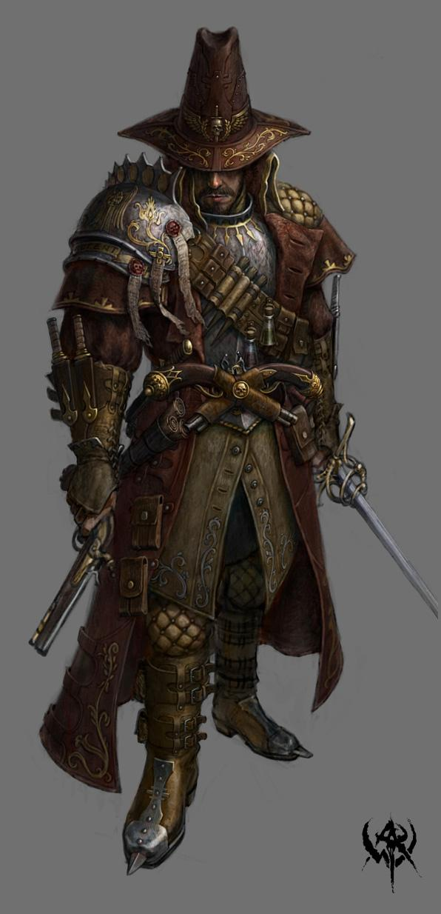

**Witch hunter:**

Hit points

Hit Dice: 1d8 per witch hunter level

Hit Points at First Level: 8 + your Constitution modifier

Hit Points at Higher Levels: 1d8 (or 5) + your Constitution modifier per witch hunter level after 1st level

Proficiencies

Armor: light armor and hunter cloaks

Weapons: simple weapons, martial weapons

Tools: alchemist tools

Saving throws: wisdom, intelligence

Skills: arcana and choose 2 from the list: History, Insight, Intimidation, Investigation, Perception, Persuasion, Religion

**hunter cloak**

|  |  |  |  |  |  |
| --- | --- | --- | --- | --- | --- |
| Armor | cost | armor class | strength | stealth | weight |
| hunter cloak(light) | non-acquirable | 12+dex | - | disadvantage | 12 |
| padded hunter cloak(medium) | non-acquirable | 14+dex (to a max of 3) | 14 | disadvantage | 20 |
| plated hunter cloak(heavy) | non-acquirable | 17 | 16 | disadvantage | 25 |

|  |  |  |  |
| --- | --- | --- | --- |
| level | proficiency bonus | focus points | features |
| 1st | + 2 | 1 | Focus Points, Mage Slayer |
| 2nd | + 2 | 2 | Focus Fighting |
| 3rd | + 2 | 3 | hunter archetype |
| 4th | + 2 | 4 | extra attack |
| 5th | + 3 | 5 | antimagic |
| 6th | + 3 | 6 | ability score improvement |
| 7th | + 3 | 7 | archetype ability |
| 8th | + 3 | 8 | ability score improvement |
| 9th | + 4 | 9 | - |
| 10th | + 4 | 10 | archetype ability |
| 11th | + 4 | 11 | - |
| 12th | + 4 | 12 | ability score improvement |
| 13th | + 5 | 13 | extra attack |
| 14th | + 5 | 14 | ability score improvement |
| 15th | + 5 | 15 | archetype ability |
| 16th | + 5 | 16 | ability score improvement |
| 17th | + 6 | 17 | improved antimagic |
| 18th | + 6 | 18 | archetype ability |
| 19th | + 6 | 19 | ability score improvement |
| 20th | + 6 | 20 | Witch sense |

**Focus Points**

At first level the Witch Hunter class gains Focus Points. Focus Points are the Witch Hunters ability to access the Anti-magic within them or to use the advanced training they have received, the amount of Focus Point you have can be found on the Level up chart. Replenish your focus points after a short rest.

**focus fighting**

at 2nd level gain, you can spend 1 focus point to add your dexterity or strength modifier to attack or damage rolls in melee, and dexterity or wisdom on ranged attacks for the next turn, you may pay an additional focus point to add this bonus on additional turns, you may pay the focus point cost twice to apply both modifiers.

**extra attack**

Beginning at 4th level, you can attack twice, instead of once, whenever you take the attack action on your turn, at13th level gain the ability to make an additional attack this way.

**Antimagic**

at 5th level, can cast the following spells for there focus point cost,they count as anti-magic not magic. your spellcasting ability is wisdom, your spellcasting bonus is equal to your proficiency bonus + wisdom modifier, and your spell save DC is equal to your witch hunter level + your wisdom modifier +5.

|  |  |
| --- | --- |
| focus point cost | spell |
| 1 | detect magic |
| 3 | counterspell |
| 3 | dispel magic |
| 3 | remove curse |
| 8 | antimagic field |

**Improved Antimagic**

at 17th level you gain, if you hit successfully with a melee or ranged attack you can spend focus points as a free action to cast antimagic. you can also spend additional focus points on each spell cast to increase its spell level by that much.

**Witch Sense**

at 20th level you gain, you have truesight on all spellcasters within 60ft.

**Hunter Specialization**

At 3rd level, you choose an archetype that will decide your specific tactics and skills. Choose Executioner, Mage Slayer, or Pistoleer, all detailed at the end of the class description. The archetype you choose grants you features at 3rd level and again at 7th, 10th, 15th and 18th level.

**Ability Score Improvement**

When you reach 4th level, and again at 6th, 8th, 12th, 14th, 16th, and 19th level, you can increase one ability score of your choice by 2, or you can increase two ability scores of your choice by 1.As normal, you can't increase an ability score above 20 using this feature.

**Hunter Archetype**

The training of witch hunter is based around the three forms of combat so that a team of witch hunters may fight effectively on all front of ranged, melee, and magical combat. The Hunter Archetype you choose will decide your role on the battlefield.

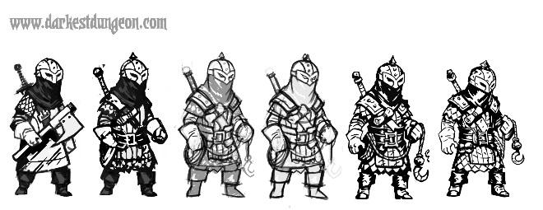

**Executioner**

The archetype Executioner focuses on melee combat, using strength and specialized tools to draw the enemy close and deal devastating blows. Those who choose this archetype are tacticians who combine strategy with brute force to change the tide of battle

**the rope and axe**

Beginning when you choose this archetype at 3rd level, you gain proficiency with medium armor, one Artisan’s tool of your choice, and the hook rope and the hunters axe

|  |  |  |  |  |
| --- | --- | --- | --- | --- |
| Name | cost | damage | weight | properties |
| Hook Chain | 5gp | 1d4 piercing | 1 lb. | Light, Special, thrown (20/60) |
| Hunters Axe |  | 1d6 slashing |  | hunter's weapon |

**Hook Chain**. when a creature of the wielder's size or lower is hit by an attack with this weapon you may spend a bonus action to have, the creature make a strength saving throw vs the wielder's strength check or else they are either grappled, knocked prone, or pulled 5ft towards the wielder, the wielder can choose the effect

**Hunter's Weapon:**

|  |  |  |  |  |
| --- | --- | --- | --- | --- |
| witch hunter level | 1-6 | 7-12 | 13-18 | 19-20 |
| damage die | 1d6 | 1d8 | 2d4 | 2d6 |
| attack and damage bonus | +0 | +1 | +2 | +3 |

**Tactical Mind**

Starting at 7th level, if you spend at least 1 minute observing or interacting with another creature outside combat, you can learn certain information about its capabilities compared to your own. The DM tells you if The creature is your equal, superior, or inferior in regard to two of the following characteristics of your choice:

* Strength Score
* Intelligence Score
* Armor Class
* Current hit points
* If they are a caster or not

**Advanced Armor Training**

At 10th level, gain proficiency with heavy armor, you do not gain the disadvantages granted by medium and heavy armors and medium armor does not have a limit to the dexterity modifier bonus that can be added to AC.

**Fearful Presence**

Starting at 15th level, your very presence in a battle brings an aura of dread, whenever you make a melee attack you can expend a Focus point to force each creature within range into fear, these creatures must make a wisdom saving throw vs a charisma check or they become frightened. Each consecutive round they must make the same save vs check to end the effect.

**Battlemaster**

At 18th level, you have harnessed the Anti-magic within you to a point where all creatures are affected by it, whenever a creature makes an attack within view, you can use a Focus Point to apply disadvantage to that attack. also when applying the effect of a hook rope instead of choosing one of the three you may choose all three.



**Mage Slayer**

The archetype Mage Slayer Focuses on the use of Anti-magic to enhance his own abilities. Those who choose this archetype utilize their innate powers to propel them into battle and hunt down powerful enemies.

**Anti-magic Enhancement**

Beginning when you choose this archetype at 3rd level, double your maximum focus points at each level, and you can expend 1 Focus point to enhance the natural abilities you already possess for 10 minutes as a bonus action

* gain advantage on intelligence and wisdom saving throws
* Non magic attacks gain advantage against you
* You gain advantage on spells you cast, and enemies making saves against your spells have disadvantage

While Anti-magic Focus is activated, the Mage Slayer can also spend Focus Points as a bonus action to further enhance his abilities

* x points, gain advantage on the next x melee attacks you make
* 1 points, use dash as a bonus action
* 1 point, gain advantage on Perception checks to see Magic items and creatures
* 1 point, gain AC equal to your wisdom modifier until your next turn
* 2 point, gain health equal to your wisdom modifier, health gained this way cannot exceed your maximum health.

**Antimagic infusement**

Starting at 7th level, you may spend 1 focus points and 5 minutes to give an item the master crafted property, further enhancement with this power cost 2 focus points. Items can only be enhanced up to master crafted rank 3.

**Font of Antimagic**

At 10th level, enemies that are positively affected by magic now have disadvantage on attacks against you and you gain resistance to damage they deal. However, enemies that are not positively affected by magic now have advantage on attacks against you and gain resistance to damage you deal.

**Improved Antimagic**

Starting at 15th level, all antimagic cast by the mage slayer is counted as cast one level higher. your maximum focus points is doubled. when you spend a focus point roll a d20 and on a 20 instantly regain that focus point.

**Anti-magic Channeler**

At 18th level, the Anti-magic within the Mage Slayer has become strong enough to grant resistance against all damage from spells and advantage on all checks against spell effects.



**Pistoleer**

The archetype Pistoleer focuses on ranged combat, using the recent invention of gunpowder projectiles to deal massive damage without getting in the thick of combat. Those who choose this archetype are inventors and engineers that use their creations to get an edge on magic users.

**Way of the Blackpowder**

Beginning when you choose this archetype at 3rd level, you gain proficiency in the tinker tools and firearms  
**Firearms.**

|  |  |  |  |  |
| --- | --- | --- | --- | --- |
| Name | cost | damage | weight | properties |
| pistol | 250gp | 1d8 piercing | 3 lb. | Ammunition (range 30/90), loading, Misfire |
| revolver | 750 gp | 2d4 piercing | 3 lb. | ammunition (range 30/60) loading 8, misfire |
| rifle | 500gp | 1d12 piercing | 7lb | Ammunition (range 40/120), loading, Misfire, two handed |
| blunderbuss | 500gp | 1d10 slashing | 10lb | Ammunition (range 5/10), loading, Misfire, two handed, special |

**Blunderbuss**. The Blunderbuss has an attack that can do multiple things depending on the range, of the weapon, at short range (5ft) the weapon deals normal damage to one target. Any attack beyond 5 feet has a 10ft cone attack that deals 1d4 slashing damage

**Ammunition**. Destroyed upon use, metal balls and gunpowder

**Reload**. takes an attack action, after using a weapon with this property the user must expend an ammunition to allow another attack action

**Misfire**. weapons with this property are delicate or unstable and have a chance to break, when making attacks with this weapon, if a 1-5 is rolled on a d20 roll, the weapon will break and have to be repaired with a full turn before it is usable again.

**Gunslingers focus**

Starting at 7th level, the Pistoleer can choose to expend focus points to enhance attack made with firearms

**Longshot**. spend 2 focus points double the range of one ranged weapon

**Fast fire**. spend a number of focus points equal to the attacks you wish to make, you can use one action to make these attacks, every attack made in this fashion increases the chance to misfire by one

**Deadshot**. enhance one attack by an extra die per Focus point, each time this is used the Misfire is increased by one for that attack

**Focused shot**. gain advantage on one attack roll, and +1 to that roll for each additional focus point spent.

**Take it down**. spend 1 focus point and make it so the next attack against a flying creature forces it to make a dexterity saving throw vs dexterity check or fall 20 ft., if the creature hits the ground because of this attack it is knocked prone.

**Called Shot**

At 10th level, the Pistoleer can choose to mark a target using his action, attacks against the marked creature have advantage, only one creature can be marked at a time. While Called Shot is effecting a creature, the Pistoleer can choose to expend a focus point to increase the base damage dice rolled by one size this turn, the Pistoleer can only do this once per turn.

**Tactical Retreat**

Starting at 15th level, whenever a melee attack hits the Pistoleer, the Pistoleer may choose to move half their movement away from them as a reaction without incurring opportunity attacks. for each opportunity attack that this character would have incurred you may take a free action to make an attack on the source.

**Battlefield Engineer**

At 18th level, Reloading and repair takes a bonus action, a Pistoleer can also spend a minute outside of combat to activate one gunslinger focus without using Focus points, they can use this ability a number of times equal to their maximum focus points

backstory:

During the event known as the Lightfall, the Arcane leyline under the city of the Magelight were hit by a massive amount of dark energy, resulting in a shock wave of anti-magic. those caught in the resulting shockwave had their homes decimated and families killed, those that survived were forever changed. Many of the survivors banded together under the idea that this was the doing of magic users and that they are too dangerous to be allowed on this earth, thus The Nightwatch was born. when the Nightwatch was founded 3 of of its founding members dedicated themselves to the hunting and destruction of witchcraft, these three st.mikhail the gunslinger, st.serin the soulless, and st.drek the brutal founded the three unique styles of witch hunters that are found today. st.darius of the shadows and st.mortius the wanderer where the first two inquisitors. the first exalted priest lord was st.athanasius the bold, his counsel included dranias the corrupt, st.jonas the pure, and st.harkus the courageous.

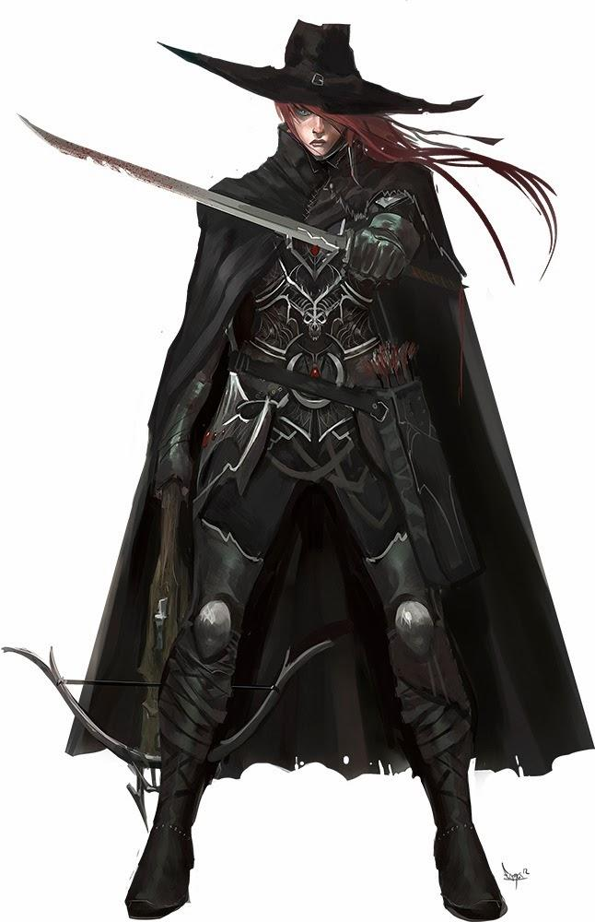

**Inquisitor**

Like the witch hunters the inquisitors are warrior priests of the Nightwatch but instead of looking through the lands for sinners inquisitors look through the Nightwatch itself and the commoners that worship at its church. much less forgiving and humane than witch hunters inquisitors are trained from birth to be heartless and cold, most find there near soullessness and absolute faith to be severely unnerving.

Class

**Hit points**

Hit Dice: 1d10 per witch hunter level

Hit Points at First Level: 10 + your Constitution modifier

Hit Points at Higher Levels: 1d10 (or 6) + your Constitution modifier per inquisitor level after 1st level

**Proficiencies**

Armor: medium and light armor, shields

Weapons: martial and simple weapons

Tools: alchemy tools

Saving throws: wisdom, constitution

Skills: arcana, choose 3 from: athletics, survival, intimidation, insight, perception, investigation, History, Persuasion, Religion

|  |  |  |  |
| --- | --- | --- | --- |
| level | proficiency bonus | fury | Features |
| 1st | + 2 | 1 | Purity seals, fighting style |
| 2nd | + 2 | 2 | Inquisitive |
| 3rd | + 2 | 2 | Inquisitor domain |
| 4th | + 2 | 3 | Ability score improvement |
| 5th | + 3 | 3 | - |
| 6th | + 3 | 3 | Ability score improvement |
| 7th | + 3 | 4 | domain ability |
| 8th | + 3 | 4 | - |
| 9th | + 4 | 4 | Ability score improvement |
| 10th | + 4 | 4 | domain ability |
| 11th | + 4 | 5 | - |
| 12th | + 4 | 5 | Eternal fire |
| 13th | + 5 | 5 | - |
| 14th | + 5 | 5 | Additional fighting style |
| 15th | + 5 | 5 | domain ability |
| 16th | + 5 | 6 | Battle faith |
| 17th | + 6 | 6 | - |
| 18th | + 6 | 6 | Hardened inquisition |
| 19th | + 6 | 6 | - |
| 20th | + 6 | all | Eternal crusade |

Purity seals: whenever you gain a fury point you may gain one of the following abilities;

· You have advantage on creatures that are frightened

· You have advantage on wisdom saving throws

· +1 to attack and damage rolls

· +2 to attack rolls

· +2 to damage rolls

· +1 to ac and initiative

· +2 to ac

· +2 to initiative

· You can make an additional reaction in-between your turns by expending hit die

· On a critical success on an attack all enemies within 5ft of the target take 1d4 fire damage

· If you deal fatal damage to a creature all enemies within 5 ft take 1d4 fire damage

· Your hit point maximum is increased by 20

**Fighting styles:**

Archery You gain a +2 bonus to attack rolls you make with ranged weapons.

Defense While you are wearing armor, you gain a +1 bonus to AC.

Dueling When you are wielding a melee weapon in one hand and no other weapons, you gain a +2 bonus to damage rolls with that weapon.

Great Weapon Fighting When you roll a 1 or 2 on a damage die for an attack you make with a melee weapon that you are wielding with two hands, you can reroll the die and must use the new roll, even if the new roll is a 1 or a 2. The weapon must have the two-handed or versatile property for you to gain this benefit.

Protection When a creature you can see attacks a target other than you that is within 5 feet of you, you can use your reaction to impose disadvantage on the attack roll. You must be wielding a shield.

Two - w e a p o n Fighting When you engage in two-weapon fighting, you can add your ability modifier to the damage of the second attack.

**Inquisitive:** creatures that are afraid of you that make history checks after you have passed an intimidation check have advantage on said history checks.

**Eternal fire:** if an enemy was dealt fire damage last round then on its turn this round it is dealt that same amount of damage again but in piercing damage.

**Battle faith:** whenever you critically hit an enemy or kill an enemy regain 1d4 hit points.

**Hardened inquisition**: non -magical creatures cannot lie to you or withhold information from you.

**Eternal crusade**: if you would be reduced to 0 hit points and you're the last surviving member of your party then you instantly regain half of your hitpoints

**Inquisitor domains**:

The inquisitors focus mainly on one the three fundamental domains, combatants of the enemy within, the enemy without, and the enemy beyond

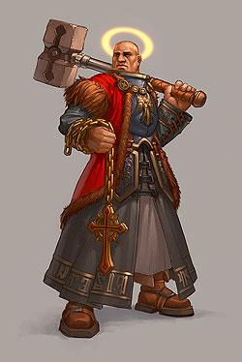

**The enemies within**:

This branch of the inquisition was formed to combat heresy within the church, destroy it before it could spread and keep those that would fall out of line from doing so.

**3rd**: as a reaction target ally who failed a wisdom saving throw may expend a hit die to reroll the die with advantage

**7th**: spells cast by enemies that target your allies that miss cause the source to take 1d4 fire damage.

**10th**: you an all of your allies have advantage on any enemies that are feared, and feared enemies have disadvantage on you and your allies

**15th**: if an enemy is afraid of you you can spend a full action to make it completely obedient to your every command, it can at any time attempt to break free of from your command by making a wisdom saving throw, each time it fails this saving throw reduce its maximum hit points by 1.

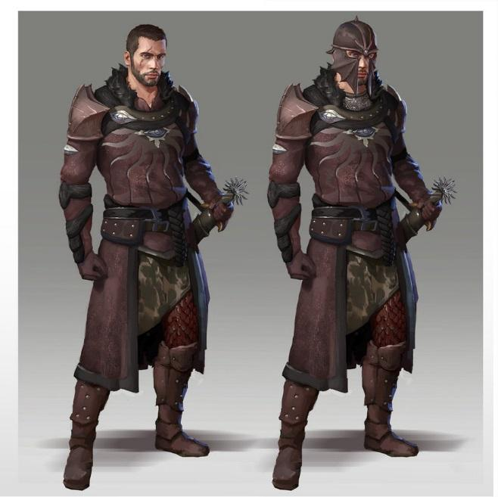

**The enemies without:**

This branch of the inquisition was formed to combat heresy outside of the church on a semi local scale, their purpose is to roam the churches territory rooting out heresy from the peasantry and aiding witch hunters in home turf.

**3rd**: you have advantage on intimidation checks on non-magical creatures

**7th**: if you succeed on an intimidation check on non-magical creatures whose level is lower than yours they must obey your commands until they believe you have freed them or died. To a maximum of one moon.

**10th**: target creature that fears you must make a wisdom saving throw, on a failed roll it takes 6d6 fire damage, on a passed it take half as much.

**15th**: you can spend a free action causing any enemy that fears you to immediately become blinded, charmed, deafened, grappled, incapacitated, paralyzed, prone, restrained, stunned, or unconscious, you may not use this if you have already used it this turn.

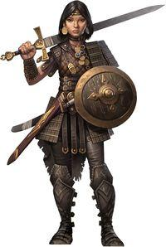

**The enemies beyond**:

This branch of the inquisition was formed to combat heresy on a universal scale, the inquisitors chosen for this order are the cream of the crop significantly more adept than the other the combatants of the enemies beyond have jurisdiction via the church from anywhere.

**3rd**: you can spend a bonus action or reaction focusing your fury into searing hot antimagic in your blade, the next attack you make with this weapon deals an additional 1d4 fire damage

**7th**: creatures you deal damage to or creatures that fail to hit you with an attack must make a wisdom saving throw against you and if they fail they are afraid of you until the end of your next turn.

**10th**: during a creature's turn if it is frightened by you it takes xd4 fire damage, where x is the number of turns this encounter that it has been frightened by you +1.

**15th**: during your turn you gain an additional full action for each creature in the encounter that is frightened of you.

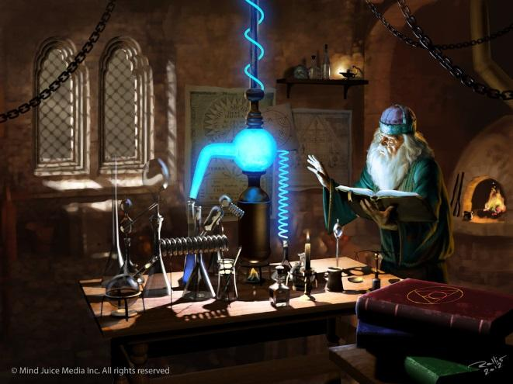**The Alchemist**

|  |  |  |  |
| --- | --- | --- | --- |
| Level | Proficiency | Features | Discoveries |
| 1 | +2 | Spellcrafting, Alchemical Specialization | 0 |
| 2 | +2 | Specialization feature | 0 |
| 3 | +2 | Discoveries | 2 |
| 4 | +2 | Ability Score Improvement | 2 |
| 5 | +3 | Discovery | 3 |
| 6 | +3 | Specialization feature | 3 |
| 7 | +3 | Discovery | 4 |
| 8 | +3 | Ability Score Improvement | 4 |
| 9 | +4 | Discovery | 5 |
| 10 | +4 | Specialization feature | 5 |
| 11 | +4 | Discovery | 5 |
| 12 | +4 | Ability Score Improvement | 6 |
| 13 | +5 | Discovery | 6 |
| 14 | +5 | Specialization feature | 6 |
| 15 | +5 | Discovery | 7 |
| 16 | +5 | Ability Score Improvement | 7 |
| 17 | +6 | Discovery | 7 |
| 18 | +6 |  | 8 |
| 19 | +6 | Ability Score Improvement, Discovery | 8 |
| 20 | +6 | Grand Discovery | 8 |

**Spellcrafting**

Formulae book - at 1st level, you have a book containing the formulae for 3 1st level Alchemist elixirs of your choice. If you find a formulae book you can copy the elixirs into your own (so long as you can prepare elixirs of that level and have the time to decipher the formula). You can do the same with a Wizard’s spellbook, if the spells are also on the alchemist formulae list. It takes one hour per elixir level to transcribe an elixir from a formulae book, and two hours per level to translate and then transcribe a spell from a spell book. It also costs 50 gp per elixir level, representing the material cost involved to purchase and prepare the correct reagents.

Replacing the book is a little easier - it only costs thirty minutes and 10 gp per elixir level to copy an elixir formulae into a new book. If you have lost the book, however, you can transcribe the elixirs you have prepared and that are still fresh in your memory, but you will have to find other books to copy. Protect your formulae book!

Alchemists perform feats of magic by means of careful preparation and crafting ability. Alchemists create elixirs which replicate the effects of magical spells. Unless stated otherwise, an Alchemist’s elixirs function precisely as the spell would, but an alchemist cannot normally share her elixirs to confer those benefits on others. Only an Alchemist has the stomach to imbibe her magical mixtures, and all spell effects affect the Alchemist who drank the elixir. Consuming the elixir is an action.

You prepare elixirs similar to the way a Wizard prepares spells. After a long rest, you choose and then prepare a number of elixirs from your formulae book equal to your Elixirs Per Day as outlined in the Elixirs Table. The elixirs must be of a level you are able to craft. It takes you 1 minute per elixir level to prepare that elixir. You can choose to not prepare all your spells at once - for example, upon starting the day, an alchemist of 3rd level may wish to prepare one first level and one second level elixir, leaving two first level elixir slots open.

You can prepare elixirs of any level you can create - for example, if an elixir is 1st level, you may expend an elixir slot of 3rd level to prepare that elixir at 3rd level.

Spellcrafting ability - Your spellcrafting ability is Intelligence.

**Elixir Save DC**: 10 + your proficiency bonus + your Intelligence Modifier

**Elixir Attack Bonus**: your proficiency Bonus + your Intelligence Modifier

Learning Elixirs of 1st Level or Higher - Each time you gain an Alchemist level, you learn one new elixir of any level you can prepare. You can also find new formulae and add them to your book, as outlined in the Formulae Book section.

|  |  |  |  |  |  |  |
| --- | --- | --- | --- | --- | --- | --- |
| Alchemist Level | Elixirs Known | Elixirs per Day | | | | |
| Level |  | 1 | 2 | 3 | 4 | 5 |
| 1 | 2 | 1 | - | - | - | - |
| 2 | 3 | 2 | - | - | - | - |
| 3 | 4 | 3 | 1 | - | - | - |
| 4 | 6 | 3 | 2 | - | - | - |
| 5 | 7 | 4 | 3 | 1 | - | - |
| 6 | 9 | 4 | 3 | 2 | - | - |
| 7 | 10 | 4 | 4 | 3 | 1 | - |
| 8 | 12 | 5 | 4 | 3 | 2 | - |
| 9 | 13 | 5 | 4 | 4 | 3 | - |
| 10 | 15 | 5 | 5 | 4 | 3 | 1 |
| 11 | 16 | 5 | 5 | 4 | 4 | 2 |
| 12 | 18 | 5 | 5 | 5 | 4 | 2 |
| 13 | 19 | 5 | 5 | 5 | 4 | 3 |
| 14 | 21 | 5 | 5 | 5 | 5 | 3 |
| 15 | 22 | 5 | 5 | 5 | 5 | 3 |
| 16 | 24 | 5 | 5 | 5 | 5 | 4 |
| 17 | 25 | 5 | 5 | 5 | 5 | 4 |
| 18 | 26 | 5 | 5 | 5 | 5 | 4 |
| 19 | 27 | 5 | 5 | 5 | 5 | 5 |
| 20 | 30 | 5 | 5 | 5 | 5 | 5 |

**Alchemical Specialization**

At first level, an Alchemist chooses his/her specialization, representing his/her area of focus. The following three are presented here:

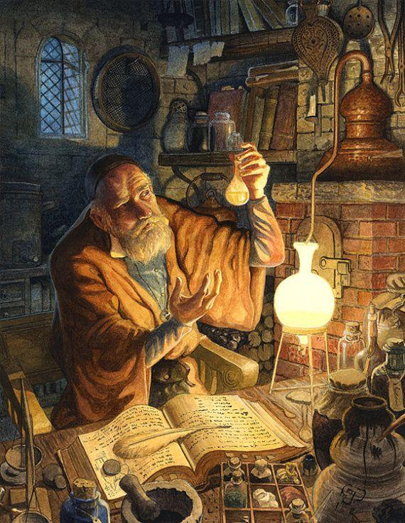

* Mutagenic
  + The Mutagenic Alchemist drinks potent potions to transform herself into a souped-up bruiser, at the expense of her mental acuity.
  + Level 1: In addition to the elixirs you create, you can make a mutagenic mixture that transforms your body into a hulking, muscular form. You can make a number of mixtures equal to your Intelligence modifier per day. You may consume the mutagen as a bonus action, but doing so provokes attacks of opportunity. Only you can consume this mixture - anyone else who tries is sickened until their next turn. Each use of the mutagen mixture lasts for one minute. While mutated, you have the following traits:
    - You gain twice your level as temporary hitpoints.
    - You have advantage on melee attack rolls, and enemies have advantage on melee attack rolls that target you.
    - You have advantage on Strength checks and Strength saving throws.
    - You have disadvantage on Intelligence checks and Intelligence saving throws.
  + Level 2:
    - While under the effects of a mutagen, you gain a natural weapon (a claw, horn, or tail) that deals 1d6 damage.
  + Level 6:
    - While under the effects of a mutagen, you have resistance to bludgeoning, piercing, and slashing damage, and your speed increases by 10 feet.
  + Level 10:
    - While under the effects of a mutagen, after making a successful melee attack you can attempt a Strength check, DC 10 + the target’s Strength modifier + the target’s level. If you succeed, you can choose to knock the target prone, move the target 5 feet, or do additional 1d4 damage.
  + Level 14:
    - While under the effects of a mutagen, your melee reach extends by 5 feet. You no longer need to consume your mutagen - prolonged exposure has enabled you to turn it on at will.
  + Level 18:
    - Your strength and constitution are both permanently increased by 2. While under the effects of a mutagen, your speed is increased by a further 10 feet, to a total of 20 feet bonus. You have no limit to the number of times you can use your mutagen.



* Bomber
  + The Bomber Alchemist creates powerful explosives and other thrown items to engage with the enemy from afar
  + Level 1:
    - You can create a number of bombs equal to your Alchemist level per day. Creating and throwing a bomb counts as one action, total. To throw a bomb is a ranged attack (so you add your dexterity and compare vs armor class). Bombs deal 1d6 + your Intelligence modifier damage to the target and in a 5 foot radius from the target (creatures in this radius can make a Dexterity save of your Elixir Attack DC for half damage). On a miss, everyone in the area takes minimum damage and can make a Dexterity save for half damage.The normal range of your bombs is 20 feet, the long range is 60 feet.
  + Level 2:
    - You can add your proficiency bonus to the ranged attack rolls for your bombs and simple thrown weapons.
  + Level 6:
    - Your bombs now deal 3d6 + your intelligence modifier damage. This bonus increases by 1 die every 2 levels (e.g. 4d6 at level 8) to a maximum of 10d6 at level 20.
  + Level 10:
    - Your exposure to explosives has made you especially careful. You have advantage when you make a dexterity saving throw to take only half damage, and you take no damage on a success.
  + Level 14:
    - After throwing a bomb as a full action, you can throw an additional bomb as a bonus action.
  + Level 18:
    - You can create deadly bombs that can destroy structures and tunnel through stone. These large bombs take 3 rounds to detonate and have a radius of 60 feet. Creatures caught in the blast take 15d6 damage. You must take a long rest before you can make another bomb of this type.

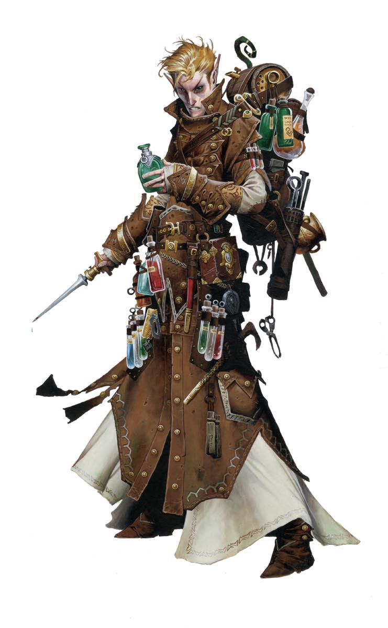

* Poisonous
  + The Poisonous Alchemist learns how to create and handle deadly poisons and oils, to engage in subtle warfare
  + Level 1:
    - The Poisonous Alchemist can create a vial of poison (as the item in the player’s handbook, pg 153) and apply it to her weapon. The alchemist can do this a number of times equal to her Intelligence modifier per day.
  + Level 2:
    - Due to prolonged exposure to poisons, the alchemist has advantage on rolls to save against poison and resists poison damage. The number of dice for the extra damage that your poison deals now increases with your level, and you deal an additional die of poison damage for each two Alchemist levels (e.g at level 4, your poisons deal 2d4 damage, at level 10, 5d4, etc).
  + Level 6:
    - When the Alchemist prepares a poison, she can instead make a poison to be ingested. Anyone who drinks the poison loses ¼ of their HP per day for a week. Each day the target makes a constitution save at disadvantage against the Alchemist’s Elixir Attack DC - on a success, no HP is lost. A healer with a healer’s kit and a successful Wisdom (Medicine) check (against the Alchemist’s Elixir Attack DC) can remove the poison.
  + Level 10:
    - The maximum number of poisons you can make increases by 5. You have advantage on attacks you make with poisoned weapons.
  + Level 14:
    - By spending an additional 50% on time and resources to make each poison you can place a vial of poison that when a non friendly creature enters within five feet of it activates and each creature in a 10 ft. radius must make a constitution saving throw versus your elixir attack dc. Targets take 7d4 poison damage (half damage on a save). This poison damage increases by 1 die every 2 levels (to 8d4 at level 16, 9d4 at level 18, and 10d4 at level 20).
  + Level 18:
    - Your poisons are so potent that they ignore resistance. When you apply a poison, you can choose to apply a special, dire poison that does 15d4 damage and leaves the target weakened for one minute. You must wait until you have a long rest until you can apply this poison again.

**Discoveries**

Discoveries represent the tinkering and tuning that the Alchemist makes to her creations during her time adventuring. Beginning at 3rd level, and then every other level, the Alchemist chooses a discovery from the Discoveries List to augment her craft. (Individual discoveries have a level requirement, and so need to be balanced that way)

· Mutagen: While mutated, you are immune to critical hits

· Mutagen: Go up a size class (Medium->Large) while mutated

· Mutagen: Natural weapon damage die increases to d8

· Mutagen: While under the effects of your mutagen, gain wings and a fly speed

· Mutagen: you gain natural armor 2

· Mutagen: you gain natural armor 5

· Mutagen: you resist spell damage.

· Mutagen: you can spend a mutagen to instead boost your mental acuity, gaining a bonus on intelligence saves and checks for the duration of your mutagen.

· Mutagen: once per short rest you can make a terrifying bellow that frightens foes (wisdom save)

· Mutagen: you no longer grant advantage to melee attackers.

· Bomb: your bombs can deal fire, lightning, cold, force, or radiant damage.

· Bomb: bomb damage die increases to d8.

· Bomb: you can attach bombs to ammunition.

· Bomb: the explosion radius of your bomb is doubled.

· Bomb: your bombs can deal poison or acid damage, and cause a persisting cloud of gas.

· Bomb: you can throw a healing bomb

· Bomb: creatures in the explosion radius of your bomb must make a wisdom save (at your Elixir Attack DC) or they are confused/stunned

· Bomb: you can throw a tanglevine bomb that immobilizes or slows creatures

· Bomb: your range on thrown items is increased by 10 feet (ie short range becomes 30 feet, long range becomes 70 feet).

· Poison: your poison damage die increases to d6

· Poison: you can make a poison that when ingested instead causes the target to fall unconscious

· Poison: your poisons can affect even outsiders, who are normally immune to poisons.

· Poison: you can make an oil that damages constructs or other mechanical beings.

· Poison: you can make a poison that deals constitution damage

· Poison: you can make a poison that deals intelligence damage

· Poison: you can make a poison that paralyzes the target (Constitution save vs your Elixir Attack DC)

· Poison: you can make a poison that, when ingested, charms the target (Wisdom save vs your Elixir Attack DC)

· Poison: your skin changes colors, letting you add your proficiency bonus on Dexterity (Stealth) checks.

· You can expend an elixir slot to create a healing potion that heals 1d8 points of damage per elixir slot expended. This healing potion can be shared with others.

· Your elixirs can be shared with others

· You can revive individuals who have been dead for a number of years less than your level multiplied by 5 (by using an elixir slot)

· You can create zombies (by using an elixir slot)

· You can create clones (by using an elixir slot)

· The elixirs you create have double the duration (to a maximum of 24 hours)

· You can transmute metals into other metals - 1 gram per point of intelligence per day. (by using an elixir slot)

· You can create ooze bottles that, when broken, release an ooze to fight for you (Int mod per day)

**Grand Discoveries:**

· Poison: you can deliver a poison touch attack

· Mutagen: You no longer age. While mutated, you heal 5 HP each round.

· You can create philosopher’s stones

· Bomb: You can create unlimited bombs per day

· Choose a level 6-9 spell - you can replicate its effect as an elixir

**Elixir List**

* 1st Level
  + Animal Friendship
  + Bless (targets only self)
  + Cure Wounds
  + Comprehend Languages
  + Detect Magic
  + Disguise Self
  + Expeditious Retreat
  + Feather Fall (targets yourself)
  + Grease
  + Heroism
  + Identify
  + Jump
  + Longstrider
  + Mage Armor
  + Shield
* 2nd Level
  + Aid (targets only self)
  + Alter Self
  + Barkskin
  + Beast Sense
  + Blur
  + Continual Flame
  + Darkvision (you have darkvision)
  + Enhance Ability
  + Enlarge/Reduce (target's yourself)
  + Find Traps
  + Flame Blade
  + Detect Thoughts
  + Invisibility
  + Lesser Restoration
  + Levitate
  + Misty Step
  + Pass Without Trace
  + Protection from Poison
  + See Invisibility
  + Spider Climb
* 3rd Level
  + Blink
  + Fly
  + Gaseous Form (targets yourself)
  + Haste
  + Magic Circle
  + Meld into Stone
  + Nondetection
  + Protection from Energy
  + Remove Curse
  + Speak with Dead
  + Speak with Plants
  + Stinking Cloud
  + Tongues
  + Vampiric Touch
  + Water Walk
  + Water Breathing
* 4th Level
  + Arcane Eye
  + Aura of Life
  + Aura of Vitality
  + Death Ward (targets yourself)
  + Dimension Door
  + Evard’s Black Tentacles
  + Fire Shield
  + Freedom of Movement (targets yourself)
  + Greater Invisibility
  + Insect Plague
  + Polymorph
  + Stoneskin
* 5th Level
  + Contact Other Plane
  + Contagion (grants touch attack)
  + Dream
  + Greater Restoration
  + Scrying
  + Telekinesis
  + Tree Stride



**Warlock Patron: The Iron Crown**

You have made a pact with the power of cold iron, a power that seems to warp and even nullify magic. Unlike other warlock pacts, which reach out to entities from other planes, cold iron is a feature of the material plane, and those warlocks who seek out its power are often fierce individualists and despise interlopers from other planes. Patrons might be powerful spirits of the material plane, or you might draw your power from a particular place, with deep and rich veins of cold iron. You might even be fueled by an ancient oath to rebuke outsiders.

As an optional way to add more flavor to your character, you can pick from or roll on the following table of quirks associated with warlocks of the Iron Crown

-1: Your skin shimmers with a steely glint, and your hands are cold to the touch.

-2: You have a totem made of metal that you are compelled to carry at all times.

-3: You have a compulsion to destroy or take for yourself magical items used by evil creatures

-4: You have an overwhelming hatred of outsider creatures

-5: You are hesitant to negotiate with spellcasters

-6: You insist on jumping in the way of spells cast by your enemies, to better thwart the plans of mages.

Your connection to the power of cold iron grants you additional spells. The following are added to your Warlock spell list.

-1st Level

--Detect Magic/Shield

-2nd Level

--Arcanist's Magic Aura/Silence

-3rd Level

--Protection from Energy/Remove Curse

-4th Level

--Banishment/Ice Storm

-5th Level

--Greater Restoration/Cone of Cold

**Mystic Arcanum Bonuses**

-You can select these additional spells when selecting your mystic arcanum

--6th level Globe of Invulnerability

--7th level Symbol

--8th level Antimagic Field

--9th level Prismatic Wall

**-at 1st level**

--the nature of your pact has started to alter the workings of your mind so that it is becoming more logical and mechanical. You may reroll saves against fear, charm, and confusion, and use the higher result.

**-at 6th level**

--When you see a spell being cast, you can roll an Intelligence (Arcana) check as an immediate reaction to identify the spell, and you add your proficiency bonus to that roll. The DC of the check is the caster’s Spell Save DC. Identifying a spell this way grants you a +1 bonus to any rolls you make to save against that spell's effects.

**-at 10th level**

--You have learned some of the secrets of your patron's anti-magical aura. When you are targeted by a spell that you can detect, you can use your reaction to activate a barrier of antimagic. If the spell would deal damage to you, it deals half damage instead, and if you would roll to save against that spell's effects, you gain a +5 bonus to that roll. You must finish a short or long rest before you can use this feature again.

**-at 14th level**

--your presence is enough to distort the workings of magic and magical items. You have resistance against the damage of spells. You can also take a more active hand in disrupting spellcasters - As an action, choose a creature that can cast spells or from a plane other than the material. It must make a Constitution saving throw against your warlock spell save DC. On a failed save, the creature takes 8d10 damage, and can't cast spells until your next turn. You can instead use this feature to target a magical item. If the item is destroyed by this damage, it loses all magical properties

**Maleficus**

|  |  |  |  |  |  |
| --- | --- | --- | --- | --- | --- |
| **Level** | **Proficiency Bonus** | **Features** | **Cantrips Known** | **Spell Slots** | **Max Spell Level** |
| 1st | +2 | Essence Magic, Metamagic (Sorcerer) | 2 | 2 | 1 |
| 2nd | +2 | Arcane Tradition (Wizard) | 2 | 3 | 2 |
| 3rd | +2 | Life Magic | 2 | 4 | 3 |
| 4th | +2 | Ability Score Improvement | 2 | 5 | 3 |
| 5th | +3 | Acquire Familiar | 3 | 6 | 4 |
| 6th | +3 | Arcane Tradition feature | 3 | 7 | 4 |
| 7th | +3 | ---- | 3 | 8 | 5 |
| 8th | +3 | Ability Score Improvement | 3 | 9 | 5 |
| 9th | +4 | Metamagic, Familiar Improvement | 3 | 10 | 5 |
| 10th | +4 | Arcane Tradition feature | 3 | 10 | 6 |
| 11th | +4 | ---- | 4 | 11 | 6 |
| 12th | +4 | Ability Score Improvement | 4 | 11 | 6 |
| 13th | +5 | Familiar Improvement | 4 | 12 | 7 |
| 14th | +5 | Arcane Tradition feature | 4 | 12 | 7 |
| 15th | +5 | ---- | 4 | 13 | 7 |
| 16th | +5 | Ability Score Improvement | 5 | 13 | 8 |
| 17th | +6 | Metamagic, Familiar Improvement | 5 | 14 | 8 |
| 18th | +6 | Arcane Tradition feature | 5 | 14 | 8 |
| 19th | +6 | Ability Score Improvement | 5 | 14 | 9 |
| 20th | +6 | Call of the Ancients | 6 | 15 | 9 |

|  |  |  |
| --- | --- | --- |
| Class Features  As a maleficus, you gain the following class features.    **Hit Points**  **Hit Dice:** 1d6 per maleficus level  **Hit points at 1st Level:** 6 + your Constitution modifier  **Hit points at Higher Levels:** 1d6 (or 4) + your Constitution modifier per maleficus level after 1st    **Proficiencies**  **Armor:** Light Armor, Hide Armor  **Weapons:** Daggers, sickles, shortbows, nets, quarterstaves  **Tools:** Herbalism Kit    **Saving Throws:** Constitution, Wisdom  **Skills:** Choose two from Arcana, Athletics,  Insight, Medicine, Perception, and Stealth    **Equipment**  You start with the following equipment, in addition to the equipment granted by your background:    · (*a*) a shortbow with twenty arrows or (*b*) a dagger  · (*a*) padded armor or (*b*) an herbalism kit  · (*a*) spell components or (*b*) an essence stone  · Explorer’s Pack and a stone satchel.    **Essence Magic**  Since your entrance into this world, you have been cursed with magical abilities. No one knows how or why your kind are as they are, but legend has it that all mortals contain this ability and only a few unfortunate souls are capable of harnessing it. | **Cantrips**  At 1st level, you know two cantrips of your choice from the wizard spell list. You learn additional wizard cantrips of your choice at higher levels, as shown in the Cantrips known column of the Maleficus table.    **Stone Satchel**  At 1st level, your satchel has in it two spell stones built from 1st-level spells. Your satchel has five preparation slots and can hold 20 stones on top of that.    **Gaining, Preparing, and Casting Spells**  The Maleficus table shows the combined level total of the spell slots you can expend. To cast a spell, its level cannot exceed your current spell level maximum and you must expend spell slots equal to the spell’s level. You regain all expended spell slots when you finish a short or long rest.  For example, if you are 4th level, and you wanted to cast the spell *scorching ray*, you can spend two spell slots of your maximum of five slots to cast it as a 2nd-level spell, or you can spend three spell slots to cast it as a 3rd-level spell. This would leave you with three or two spell slots, respectively.  You gain spells differently from other spell casting classes. You are unable to invent your own spells, only copy the spells of others. To do this, you must first find a spell scroll or book. After choosing the spell you wish to copy, you must spend an hour per each of the spell’s levels to magically craft a ½ lb stone.  While not necessarily required, you can prepare a set of stones you can easily reach from in your satchel. You can put one stone in each preparation slot. You can use a bonus action to grab or replace a stone from your hand with one in a preparation slot. If you want to grab a stone not in a preparation slot, you use an action to delacare a number between 1 and 20, then roll 1d20. If the number rolled does not match the number you declared, you did not get the stone in time. |  |
| You may switch the stones in your preparation slots when you finish a short rest.  To cast a spell, you require a magic stone and either (*a*) the spell’s components or (*b*) an essence stone. To cast a spell using the its components, hold the magic stone in one hand and the components in the other. Then cast the spell normally. To cast a spell using an essence stone, hold a stone in either hand and strike the stones together and perform any other required actions.    **Spell Casting Ability**  Wisdom is your spellcasting ability for your maleficus, so you use your Wisdom modifier whenever a spell refers to your spellcasting ability. In addition, you use your Wisdom modifier when setting the saving throw DC for a maleficus spell you cast and when making an attack roll with one.    **Spell save DC** = 8 + your proficiency bonus + your Wisdom modifier    **Spell attack modifier** = your proficiency bonus + your Wisdom modifier  **Metamagic**  Your sorcery points are equal to your Wisdom modifier plus half your level, rounded down. You regain these points at the end of a long rest.    **Life Magic**  When you reach 3rd level, you can now use your hit points to cast spells. If you have no Spell Slots remaining, you may spend 3 hit points per the each of the spell’s remaining levels instead. You can bring yourself below 0 hit points in this way, but only if the hit points were spent on the spell’s final level.  For example, if you are a 4th level maleficus, you are out of spell slots, you have 5 hit points, and you wish to cast *scorching ray*, you may cast it as a 2nd-level spell but not a 3rd-level or higher spell. | **Acquire Familiar**  At 5th level, you can use your magic powers to entwine the spirit of an animal with your own. You may choose any tiny or small beast with a Challenge Rating of 0. This is the only creature that will be summoned by this feature.  If you spend five minutes in concentration, you can summon this creature at any time. It appears in an unoccupied space within 10 feet of you.  Your familiar acts independently of you, but will follow any commands you give it. You can communicate telepathically with your familiar if you are within 100 feet of each other. In combat, its initiative is immediately after yours. It can attack and take actions as normal.  You can dismiss your familiar at any time as an action. It may be instantaneously returned to any unoccupied space within 20 feet of you at anytime as an action. If you're familiar drops to 0 hit points, it must be resummoned. (concentrate for five minutes)    **Familiar Improvements**  Through the bond you both have formed and through an increase in your magical ability, your familiar has improved to better suit your needs. At 9th, 13th, and 17th levels, you can improve your familiar with new powers and strengths.  At each of these levels, you choose one improvement from the list. The improvement is given to your familiar every time it is summoned.    **Strengthened Telepathy**  While your familiar is within 100 feet of you, you take control of your familiar as an action. You see and hear what it does until the start of your next turn. You gain the benefits of any special senses your familiar has. While doing this, your own body is unconscious, blind, and deaf.    **Fiendish Resilience**  Your familiar gains resistance to a damage type of your choosing. It also does an extra d4 of damage of that type when it attacks. |  |
|  |
| **Magic Barrier**  Whenever you cast a 1st-level or higher spell, your familiar gains 7 (3d4) temporary hit points. These hit points disappear after two hours.    **Arcane Flight**  Your familiar gains 20 ft. of flying speed and can hover.    **Fiendish Infusing**  If it is within 5 ft. of you, your familiar can use its reaction to bind itself to a spell you cast that targets any creature other than yourself. The spell does an extra d6 of force damage to each target. When the spell resolves, the familiar is moved adjacent to the creature furthest away from you that was affected.    **Tricksy Bugger**  Your familiar can use an action to make itself appear as any humanoid or undead creature it has seen. Its statistics are unaffected. This is an illusion.    **Call of the Ancients**  Since you were a baby, you have heard the voices call to you. You fought them, believing that they would lead you to ruin, yet now you have come to know they seek to help you. At 20th level, the spirits of long dead spell casters guide you with eons of forgotten knowledge.  The spirit's first teach you the ways of ancient spell casters. You choose one of your cantrips to replace with any 1st level wizard spell. It acts as a cantrip.  They also offer the lend you their power. This is done in the form of Spirit Points. Spirit Points are spent the same way as, and in tandem with, hit points to cast spells. At the end of a long rest, you lose any remaining Spirit Points you have. After that, you can roll 1d4. If you roll a 4, you are rendered unconscious for 1d4 hours. If you roll a 3 or lower, roll that many d8 and add your Wisdom modifier. You gain that many Spirit Points. |  |  |
|  |

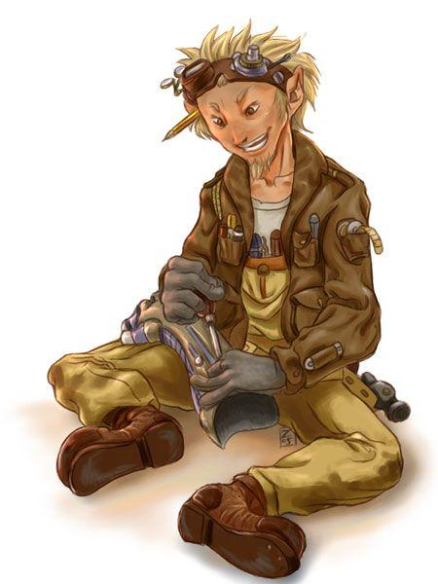

**Tinker**: you are the mechanist, the tinker, or the cogworker, however you call yourself you build intricate and profound devices to alter history, or just blow yourself up. Tinkers are intelligent and studious geniuses that often times go off on tangents and have little ways of fixing the problem at hand, per say you were confronted by a great stone wall and you needed a bomb, a tinker might begin work but ultimately come up with the world's most efficient trigger.

(animated armor, iron golem,gorgon, helmed horror, shield guardian, traps, siege equipment, vehicles(airships), locks, apparatus of kwalish, eyes of minute seeing, folding boat, iron bands of bilarro, manual of iron golems, clockwork frog, eyeglasses, manacles, telescope, spyglass, scale, magnifying glass, hunter's trap, music box, clockwork bird, animal person or monster, mechanical canary in a lamp, complex blueprints, a glass orb with a mechanical goldfish swimming inside, a mechanical crab or spider that moves when unobserved)

|  |  |  |
| --- | --- | --- |
| level | Operational contraptions | features |
| 1 | 1 | Knick knacks, contraptions |
| 2 | 1 | Tinker order |
| 3 | 1 | - |
| 4 | 2 | Ability score improvement |
| 5 | 2 | Intricate tinkerings |
| 6 | 2 | Order ability |
| 7 | 3 | Ability score improvement |
| 8 | 3 | - |
| 9 | 3 | Durable tinkerings |
| 10 | 3 | Ability score improvement |
| 11 | 3 | Stupendous tinkerings |
| 12 | 3 | Order ability |
| 13 | 3 | Advanced tinkerings |
| 14 | 3 | - |
| 15 | 4 | Powerful tinkerings |
| 16 | 5 | Ability score improvement |
| 17 | 6 | Order ability |
| 18 | 7 | Deceiving tinkerings |
| 19 | 8 | - |
| 20 | 9 | Great tinkerings |

**Knick knacks**: you can create the following things given 10 minutes and a large bin of scrap: parts, traps, locks, a small clockwork animal, eyeglasses, manacles, telescope, spyglass, scale, magnifying glass, hunter's trap, music box, clockwork bird animal person or monster, mechanical canary in a lamp, a glass orb with a mechanical goldfish swimming inside, and a mechanical crab or spider that moves when unobserved.

**Contraptions**: each order provides a tinkerer with a basis from which to create his contraptions. As a tinkerer advances in his craft he will amass more and more power, eventually being able to sustain more and more creations, the contraptions a tinkerer creates do not function unless he has an open space his contraption points as he does not have enough arcane power to sustain the contraptions inner workings throughout his travels.each tinker must set up a workshop, and in that workshop they can build the following equipment, while not in the workshop it takes them between a year and 30 days to build each item depending on the circumstances, these are at the dms discretion. Every tinker can make the following contraptions:

* Clockwork backpack with one mechanical arm, this takes up one contraption slot takes 5 days to build and requires a decent amount of scrap. If you wear the backpack it grants you an additional bonus action on your turn but you cannot make reactions.
* Steam gun, this contraption resembles a rifle but has a boiler above where the bullets go in, treat it as a rifle that ignore armor but deals -1 damage and the damage type is heat.
* Powder vest, this awkward heavy metal vest has black powder charges on it that when detonated blast nearby enemies while also propelling you in the opposite direction. As a reaction you may choose to detonate one of the numerous powder charges on the vest, all enemies within 5 ft of you must succeed a dexterity saving throw of 15 or take 2d6 piercing damage, then you move 10 ft in the direction of your choice and make the same save if you fail you are knocked prone and take 1d4 nonlethal damage. The vest takes up one contraption point and takes 5 days to build and a large amount of parts.

**Intricate tinkerings**: you can choose to make your contraptions intricate, intricate contraptions gain 5 temporary hit points but creatures other than you have disadvantage operating them.

**Durable tinkerings**: you can choose to make your contraptions more durable, if you do they require nearly two times as much scrap and at the beginning of each encounter gains 30 temporary hit points.

**Stupendous tinkerings**: you can choose to make your contraptions stupendous, if you do they require an additional contraption point but you gain truesight 10 when operating them.

**Advanced tinkerings**: you can choose to make your contraptions advanced, if you do increase there contraption points by 1, they now cause creatures attempting to make insight or knowledge checks on them to have disadvantage on said roll, and also grant advantage on sleight of hand to its operator.

**Powerful tinkerings**: you can choose to make your contraptions powerful, if you do when that contraption would be destroyed roll a d20 and on a 20 instead the contraption becomes permanent and no longer requires contraption points to function.

**Deceiving tinkerings**: you can make your contraptions deceiving, if you do increase their contraption cost by 1 and creatures making a knowledge check to decipher their purpose have disadvantage, to unknowledgeable these contraptions appear to be harmless clockwork pieces.

**Great tinkerings**: at level 20 you create one of the following artifacts,

* The heart of time: contraptions now only take you 10 minutes to assemble no matter their previous requirement
* The progenitor golem heart: your golems can now assemble golems for you
* Transmuter helmet: you can turn one ton of any material into 100 lbs of scrap metal
* Mechanical destroyer: choose a monster with a cr of 20 or lower, you create a functional mechanical replica that obeys your every command, in order to create this you must first dissect a corpse of this kind of monster and preserve its various pieces to use to create it.
* Power armor: create a suit of plate armor covered in gears steam engines and black powder pop tubes. This suit grants the user a strength and dexterity of 20 and an AC of 22 and advantage on initiative as well as advantage on all attacks made on targets within 30 feet of the user.
* Blood cogs: you create microscopic robots that you put into your body, they grant the following. You regain 10 hit points at the beginning of your turn, during your long rest you may choose two ability scores, these scores are twenty until your next long rest. You have advantage on attack rolls, saving throws, and ability checks.

**Tinker order**:

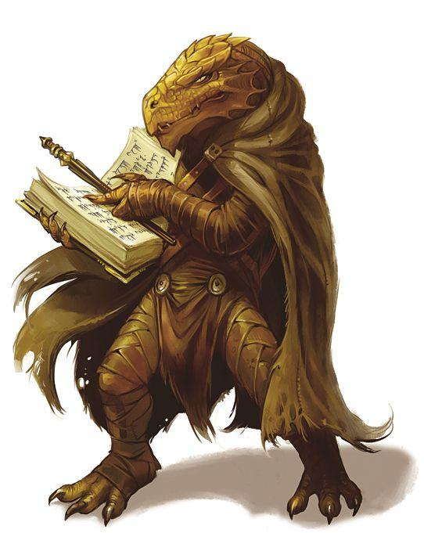

**Order of the androclock**, this order is obsessed with making mechanical humanoid life, sentience in a machine.

**2**:you can spend 3 days and a large amount of parts to build a shield guardian, it counts as one contraption

**6**: you can spend 9 days and a large amount of parts to build a animated armor, it counts as two contraption

**12**: you can spend 27 days and a large amount of parts to build a helmed horror, it counts as three contraption

**17**: you gain the complete knowledge of a manual of iron golems



**Order writhing machine**, all mechanisms are worth creating, but only some deserve to not be ripped apart and not rebuilt.

**2**:you can spend one day and a small amount of scraps to produce a single piece of siege equipment, eyes of minute seeing, or iron bands of bilarro, they each take up a single contraption point.

**6**: you can spend two days and a small amount of scraps to produce a single folding boat, it takes up two contraption points.

**12**:you can spend four days and a large amount of scraps to produce a single airship, it takes up three contraption points.

**17**:you can spend eight days and a large amount of scraps to produce a gorgon, or an apparatus of kwalish, they each take up a four contraption points.



**Order of the battle**, the contraptions you see littered on the battlefield or worn by knights or attached to the firearms and bows of rangers are created by this order. Consult the following chart when adding buffs to armor and weapons. You can only improve platemail, you can only improve ranged weapons

|  |  |  |
| --- | --- | --- |
| Contraption cost/bonus | armor(+x to ac) | weapon(+x to hit and dam) |
| Black powder | 1/+1 | 1/+2 |
| steam | 2/+3 | 1/+1 |
| Gear and cog | 2/+2 | 1/+1 |
| Double combo | 2/+4 | 2/+3 |
| Triple combo | 3/+6 | 3/+4 |

You can bolster any weapon or armor that is applicable, while it is bolstered it takes up its appropriate contraption cost. Any items modified in this way grant disadvantage on stealth checks.

**2**: armor you bolster increase the wearer's strength by 3 and decreases their dexterity by 3 and speed decreased by 5. Weapons you bolster have their range increased by 30, and gain advantage on to hit rolls against creatures in direct light.

**6**: you can bolster all heavy armor and melee weapons, armor you bolster no longer decreases your speed or dexterity.

**12**: you can bolster all medium armor, bolstered melee weapons deal an additional 1d4 bludgeoning damage and bolstered armor increases dexterity by 3 and speed by 5.

**17**: you can bolster all light armor, bolstered armor grants advantage on all attack made by the wearer and melee attacks deal double damage. Bolstered weapons increase ac by 1 and deal double damage against a creature that has already been attacked by you. Halve the contraption cost of bolstering an item and round it up.



**Life sense Ranger**

As ranger is the only class on this list that gains Spellcasting regardless of archetype, I am giving the ranger class a new feature to replace it. Please tell me why this is overpowered so that it can be adequately corrected.

**Life Sense**

Since you were a child, you could sense the difference between living things by their smell. By level 2, you have honed this ability to allow you to more easily track and fight mortals and bloodless alike. For one minute, up to three times per day, you gain advantage on any perception checks involving smell.

At level 10, you have fought around all denizens of the Thirty States enough to learn their strengths and weaknesses. You can choose to give yourself advantage on attack rolls a number of times per day equal to your Intelligence modifier.

Once you have achieved level 17, your nose is more capable than ever. You are aware of and can identify the number and kind of all mortal and Bloodless races within 80 ft. of you, unless blocked by a wall. (e.g. You can smell the skeleton in the hall to your right, but not the one in not the room on the other side of the wall.)



**Shaman(wizard subclass)**

**2nd level**, Totem: you gain a totem that focuses your magical energy, when you target an ally with a spell they have advantage on their next attack.

**6th**: allies under the effect of spells you cast can't have disadvantage on attack if they have an ally within 5 ft of them.

**10th**: whenever you cast a spell each ally within 30 feet of you can add 1d4 to there next damage roll

**14th**: you can expend a spell slot to cause the next attack target ally to gain +x to hit and maximum damage, where x is the spell slots level.



galepowder Mage**(wizard subclass)**

**2nd level**, you can store spells you know in powder jars, each jar and the powder required for storing spells takes Xd4 hours and X x 10 gold and expending a spell slot of the spell's level. Spells stored in jars can be cast by anyone with your modifiers

**6th**: you can create powder jars in half the time. You can quadruple the time it takes you to store a spell you may include a cantrip that is cast when the spell is activated.

**10th**: you can create jars and powder for half the cost.

**14th**: your jars and powder can now be used a number of times equal to ten subtract their level.

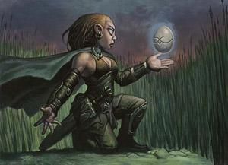

Augury mage**(wizard subclass)**

**2nd level**, you gain the lucky feat

**6th**: expend a spell slot to regain a number of luck points equal to that spell slots level

**10th**: you have advantage on lucky rolls

**14th**: you regain your lucky points after **Mystic:**

|  |  |  |  |
| --- | --- | --- | --- |
| level | proficiency bonus | Deck size | features |
| 1st | + 2 | 30 | Deck casting |
| 2nd | + 2 | 34 | Card attacks |
| 3rd | + 2 | 38 | Magic Tricks, class ability |
| 4th | + 2 | 42 | Ability score improvement |
| 5th | + 3 | 46 | Card Defense |
| 6th | + 3 | 50 | Knowledge pool |
| 7th | + 3 | 54 | Ability score improvement |
| 8th | + 3 | 58 | - |
| 9th | + 4 | 62 | Magic tricks, class ability |
| 10th | + 4 | 66 | Magic draw |
| 11th | + 4 | 70 | - |
| 12th | + 4 | 74 | - |
| 13th | + 5 | 78 | Class ability |
| 14th | + 5 | 82 | - |
| 15th | + 5 | 86 | - |
| 16th | + 5 | 90 | Ability score improvement |
| 17th | + 6 | 94 | Class ability |
| 18th | + 6 | 98 | Magic tricks |
| 19th | + 6 | 99 | - |
| 20th | + 6 | 100 | Deck master |

|  |  |  |  |  |  |  |  |  |  |
| --- | --- | --- | --- | --- | --- | --- | --- | --- | --- |
| lvl/spell | 1st | 2nd | 3rd | 4th | 5th | 6th | 7th | 8th | 9th |
| 1 | 1 |  |  |  |  |  |  |  |  |
| 2 | 2 | 1 |  |  |  |  |  |  |  |
| 3 | 2 | 1 |  |  |  |  |  |  |  |
| 4 | 2 | 2 | 1 |  |  |  |  |  |  |
| 5 | 2 | 2 | 2 |  |  |  |  |  |  |
| 6 | 2 | 2 | 2 | 1 |  |  |  |  |  |
| 7 | 2 | 2 | 2 | 2 |  |  |  |  |  |
| 8 | 2 | 2 | 2 | 2 | 1 |  |  |  |  |
| 9 | 2 | 2 | 2 | 2 | 1 |  |  |  |  |
| 10 | 3 | 2 | 2 | 2 | 1 | 1 |  |  |  |
| 11 | 3 | 2 | 2 | 2 | 1 | 1 |  |  |  |
| 12 | 3 | 2 | 2 | 2 | 1 | 1 |  |  |  |
| 13 | 3 | 2 | 2 | 2 | 1 | 1 | 1 |  |  |
| 14 | 3 | 2 | 2 | 2 | 1 | 1 | 1 |  |  |
| 15 | 3 | 2 | 2 | 2 | 1 | 1 | 1 | 1 |  |
| 16 | 3 | 2 | 2 | 2 | 1 | 1 | 1 | 1 |  |
| 17 | 3 | 2 | 2 | 2 | 1 | 1 | 1 | 1 | 1 |
| 18 | 3 | 2 | 2 | 2 | 2 | 1 | 1 | 1 | 1 |
| 19 | 3 | 2 | 2 | 2 | 2 | 1 | 1 | 1 | 1 |
| 20 | 3 | 2 | 2 | 2 | 2 | 1 | 1 | 1 | 1 |

**Class features**

As a mystic, you gain the following features

Hit points

Hit Dice: 1d8 per mystic level

Hit Points at First Level: 8 + your Constitution modifier

Hit Points at Higher Levels: 1d8 (or 5) + your Constitution modifier per Mystic level after 1st level

Proficiencies

Armor: none

Weapons: simple weapons

Tools: 3 gaming sets of your choice

Saving throws: wisdom, charisma

Skills: arcana, and choose 2 from the list: Deception, Insight, Persuasion and Religion

Equipment

You start with the following equipment, in addition to the equipment granted by your background:

* (a) a dagger or (b) a quarterstaff
* (a) a dungeoneer's pack or (b) a explorer's pack
* a component pouch
* a deck of cards



**1st Deck casting**

At first level, the Mystic gains access to the following. You can now cast spells, your spellcasting ability is charisma, your spellcasting ability check is 8 + your prof bonus + your charisma bonus, your spell attack bonus is your charisma bonus + proficiency bonus. You gain a spell deck, this is a deck of cards, each card represents a spell, you may have any number of the same spell in it, you may have a number of spells of each level so that there are no more 2nd level spells than 1st and 3rd than 2nd and so on and so on, when you choose cards you must choose cards that you will have the spell slots for next level, this always includes cantrips. You may make a constitution saving throw -x against your spell check to regain an xth level spell slot, if you don't normally have this level spell slot you gain disadvantage on this roll but if you have spell slots that are higher level you gain advantage. If you fail a roll to gain spell slots increase your exhaustion level by 1, and if it was a critical failure increase it by 2. After you cast a spell discard it. When you roll initiative roll xd4s where x is your level then draw this many cards, at the beginning of each of your turns draw a card and at the end of each of your turns discard a card. When you cast a cantrip return it to your hand after it has taken effect.

2nd card attack, you may spend a full action throwing up to 3 cards at a creature within 30ft, each card hits with magical energy searing the creature, for each card thrown discard a card and make a magic attack roll on the target, each creature hit takes 1d8 damage per card.

3rd level gain, Magic Tricks: whenever you gain this feature you gain two of the following abilities

* You may discard a card to gain a spell slot equal to its level subtract one
* You may discard a card as a bonus action to draw a card
* When you cast a spell you may discard a spell of equal or higher level to return that spell to your hand
* Whenever you fail a check to get a new spell slot draw two cards then discard one
* At the beginning of combat draw additional cards equal to your proficiency bonus, discard an additional card at the end of your turn
* When you cast a spell you may put a spell of a lower level into play under it face down, if the spell cast succeeded then cast the facedown spell without expending a spell slot, you can use this ability a number of times before taking a long rest equal to your proficiency bonus.
* You may as an action put a card from your hand face down with a specific requirement attached to it(show the dm) when this requirement the spell is immediately cast on the specified target, you then discard a card or make an exhaustion check with advantage.
* When you discard a card you may return it to your hand and put the top card of your deck into the discard pile.
* You gain access to the the fighter maneuvers as if they were spells, but your deck size is reduced by 8. (after time adventuring you pick up on minorities of fighting
* You gain access to paladin and cleric spells, but you draw one less card at the beginning of each encounter.

5th card defense: as a reaction when you are targeted with an attack, you may impose disadvantage to that attack if you discard a card.

6th Knowledge pool: you gain one of the following abilities

* Draw two additional cards each turn, and discard an additional card at the end of each turn.
* Before you draw each turn look at the top two cards of your deck, then put them back in any order or discard either of them.
* Draw an additional card each turn.

10th level magic draw:

~you may instead of drawing search your deck for three cards then put them in your hand then discard one card, you can use this ability a number of times between short rests equal to your proficiency modifier.

20th Deck master: whenever you discard a card instead put in on the bottom of your deck

**Way of the Draw**

Choose a way of the Draw, this describes the source of your magical powers and how you tend to use them: Gambler, Dealer or Reader, all detailed at the end of the Class description.

Your choice grants you a feature at 3rd level and again at 9th, 13th and 17th level.

**Way of the Draw**

Mystics are always tempters of fate. Their power derived from wild magic, playing the strings of fate and luck to either a symphony of good fortune or a discordant shriek of unfavorable events.

**Gambler**:

Tempting Fate

Starting at 3rd level, you gain the ability to twist fate in your favor for a short time. You may choose to reroll any dice roll an amount of times equal to your Charisma modifier per day, dice cannot be affected by this power more than once. After using this ability, the Dungeon Master gains a token that allows him to use this ability as well at any time, the tokens do not go away until they are used.

Magic surge gamble

Beginning at 9th level, you can roll dice to regain spell slots, roll 1d6-1d6 to gain or lose points, each spell slot costs 1 point per level to restore. If the number of spell slots you have is negative, convert the amount into exhaustion levels.

13th level

Spell gambling: expend a 4th 5th or 6th level spell slot, you gain a spell slot of level 1d8+1.

17th level

Whenever you roll a d20 you may choose to instead take the following result before you see the roll, if it's even it's a natural twenty if its odd its a natural one

**The Cheater:**

3: choose an additional number to be a critical fail and critical success on a d20 other than 20 and 1, they cannot be the same.

9: always add your proficiency modifier to d20 rolls

13: during a long rest you can choose to gain proficiency in anything of your choice, roll a d20 and on a 10 or lower you can never gain proficiency with something else.

17: if you succeed you critically succeed if you fail you critically fail

**The Bet Maker**: bets on certain actions taking place that can give positive effects on betting right but negative effects on betting wrong

A Bet with Fate

Starting at 3rd level, you can choose to make a bet. At the end of a long rest, you can choose one of these conditions:

~ gain resistance to one random damage type and vulnerability to one random damage type

~ critical hits count as critical failures and vice versa

~ increase your AC by 1d10-5

9th level

Starting at 9th level you can choose to make one of the following bets at the end a of a long rest, remove all bets at the end of your next long rest

~gain immunity to damage type of choice and x3 damage to the other

~crit on 19 and 20 critical failure on 1 and 3

~ increase your maximum hitpoints by 1d20-10

Body and Mind

At 13th level, your bet with fate can now be used for permanent changes as well as temporary ones. At the end of a long rest, you can choose one of these conditions (the 3rd and 13th level abilities count as the same power so only one condition can be chosen between the two)”

~ add 1d4 to a random skill and subtract 1d4 from a random skill

~ add 1 and subtract 1 from two random stats

~ flip a coin, on heads your speed is increased by 5 ft, on tails your speed is decreased by 5ft

17th level

You may make bets during short rests and make an additional bet

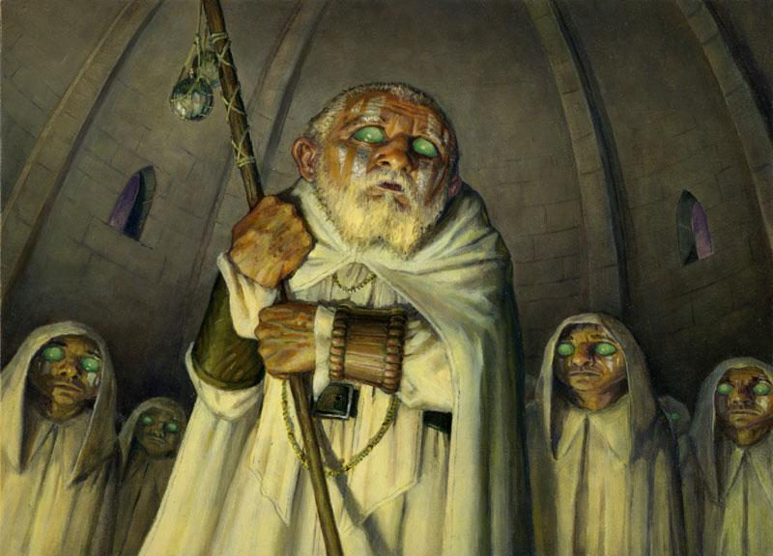

**order of the whiteclay**: cleric divine domain

starting at 2nd level, you can use revivify on a fallen ally at will without expending a spell slot for a number of minutes equal to your proficiency bonus after the encounter in which they died, you must go through a short or long rest before using this ability again.

starting at 6th level, you can use reincarnate on a fallen ally at will without expending a spell slot for a number of minutes equal to your proficiency bonus after the encounter in which they died, you must go through a short or long rest before using this ability again.

starting at 8th level, you can use resurrection on a fallen ally at will without expending a spell slot for a number of minutes equal to your proficiency bonus after the encounter in which they died, you must go through a short or long rest before using this ability again.

starting at 17th level, you can use true resurrection on a fallen ally at will without expending a spell slot for a number of minutes equal to your proficiency bonus after the encounter in which they died, you must go through a short or long rest before using this ability again.

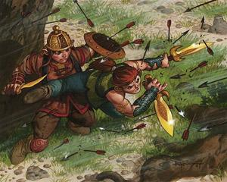

**daggerdare**: fighter martial archetype

starting at 3nd level, gain the dual wielder and defensive duelist feats when holding a one handed slashing weapon in each hand

starting at 7th level, you always have advantage on damage and attack rolls while wielding a one handed slashing weapon in both hands

starting at 10th level, enemies have disadvantage on damage and attack rolls on you while you wield a one handed slashing weapon in each hand

starting at 15th level, if an enemy makes a ranged attack at a target within 5 feet of this character it may make the following reaction, this character moves in front of the attack then makes a dexterity check against the sources attack roll, if it fails the attack hits you

starting at 18th level, whenever you are attacked in melee you may make the following reaction, make two attacks targeting the source of the last source that attacked you

**shieldare:** fighter martial archetype

starting at 3rd level: while wielding a reach melee weapon and a shield gain the polearm master and shield mastery feats

starting at 7th level: add your dex modifier to your ac, whenever your dex changes alter your ac accordingly

starting at 10th level: during your turn you may take the following full action, you gain full cover until your next turn if you are wielding a shield

starting at 15th level: attacks targeting this character gain disadvantage on attack rolls while wielding a shield

starting at 18th level: if you would be within 5 feet of an aoe attack you can make a dexterity check against the sources attack roll, if it passes move to the target square and you are the only target. your dexterity and constitution become 25 if they are lower than that.

**order of the golden cricket:** fighter martial archetype, start with a young springjack with a saddle

starting at 3rd level: gain the mounted combat feat while riding a springjack

starting at 7th level: your springjack counts as having jump and feather fall permanently cast on it

starting at 10th level: your springjack counts as having enlarge permanently cast on it

starting at 15th level: during your turn you may take the following action, make a charisma check against your springjacks charisma if it passes then your springjack gains flying speed equal to double its walking speed for the next turn.

starting at 18th level: your springjack gains large feathery wings and permanent flying speed equal to 1.5 times its walking speed, resistance to non magical attacks, its attacks count as magical, and it gains advantage on attack and damage rolls.

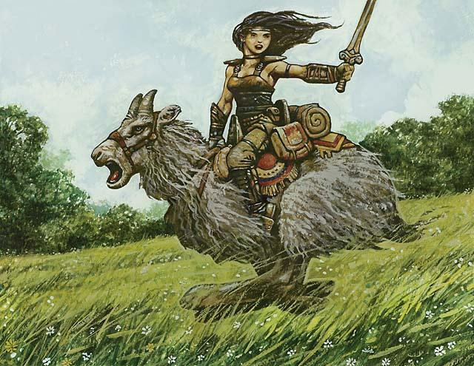

knights of meadowgrain, paladin sacred oath

|  |  |
| --- | --- |
| 3rd | Sanctuary, heroism |
| 5th | Magic weapon, continual flame |
| 9th | Crusader's mantle, blinding smite |
| 13th | Aura of purity, guardian of faith |
| 17th | Destructive wave, circle of power |

Sacred ride: while dual wielding melee weapons you may use your channel divinity to grant both weapons that you are wielding reach 10.

Turn the boggarts: use your channel divinity, all enemies within a number of feet equal to your proficiency bonus multiplied by 5 must make a wisdom saving throw against our spell save dc, on a successful save they skip their next turn, on a failed they must run from combat and are afraid of you until they are dealt a critical hit.

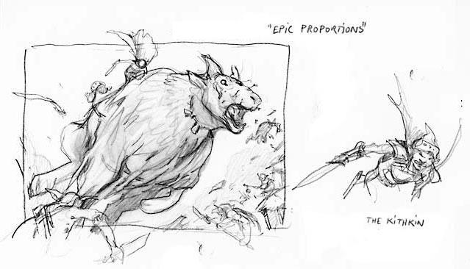

At 7th level: Great deeds: whenever you make a successful melee attack you may spend a free action using lay on hands on you or an ally, you may only heal an amount upto the damage you dealt.

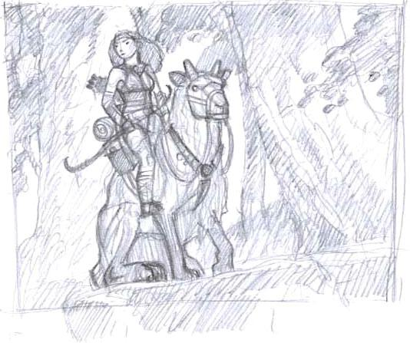

At 15th level: silence: after killing a chaotic or evil creature in melee combat you cannot speak for two days, but gain advantage on charisma checks and saving throws.

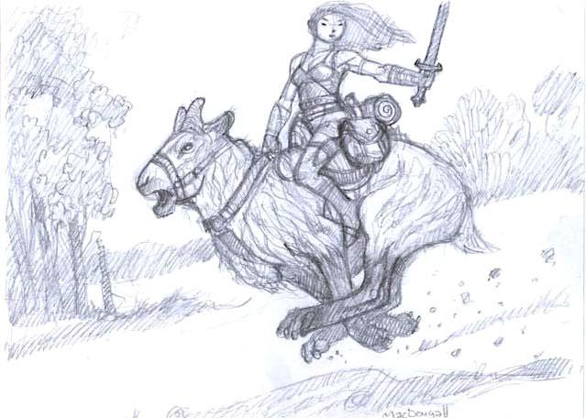

At 20th level: greater deeds: when you take lay on hands as a free action you may return hit points even if you do not have enough points in your pool of healing. While you have points available in your pool of healing you have advantage on melee attacks and checks to remain seated on your steed.

Jotun priest of the sea, paladin sacred oath

|  |  |
| --- | --- |
| 3rd | Speak with animals, thunderwave |
| 5th | Shatter, locate animal or plant |
| 9th | Glyph of warding, blinding smite |
| 13th | Stoneskin, aura of life |
| 17th | Banishing smite, scrying |

Ocean madness: you may spend your channel divinity to make it so no creature can understand you for one hour

Raiders frenzy: use your channel divinity, for the next minute your weapon attacks deal an additional amount of damage equal to your proficiency bonus and also gain temporary hit points at the start of your turn equal to your proficiency bonus

At 7th level: ebb of the tide: you may charge without incurring attacks of opportunity if you are at full health

At 15th level: bounty: this character is adept at looting and stripping enemies of their items, halve the time it takes you to loot items in general

At 20th level: aspect of the god of crashing waves: you have advantage on strength rolls.

feeder of the hunger, paladin sacred oath

|  |  |
| --- | --- |
| 3rd | Speak with animals, unseen servant |
| 5th | enlarge or reduce, locate animal or plant |
| 9th | Glyph of warding, plant growth |
| 13th | Stoneskin, aura of life |
| 17th | Banishing smite, scrying |

aspect of hunger: you may spend your channel divinity to make it so that for the next minute unarmed attacks that you make that would bring its target to 0 hit points destroy it from existence and gain temporary hit points equal to your level

vacuum: use your channel divinity, for the round all items small enough to fit in your sac are pulled towards it at slow speeds

At 7th level: feeding: if you fed the hunger enough yesterday you have advantage on death saving throws

At 15th level: you can feed the hunger pure magic, by concentrating

At 20th level: disciple of the hunger: you can cast enlarge/reduce at will targeting yourself

Prestige classes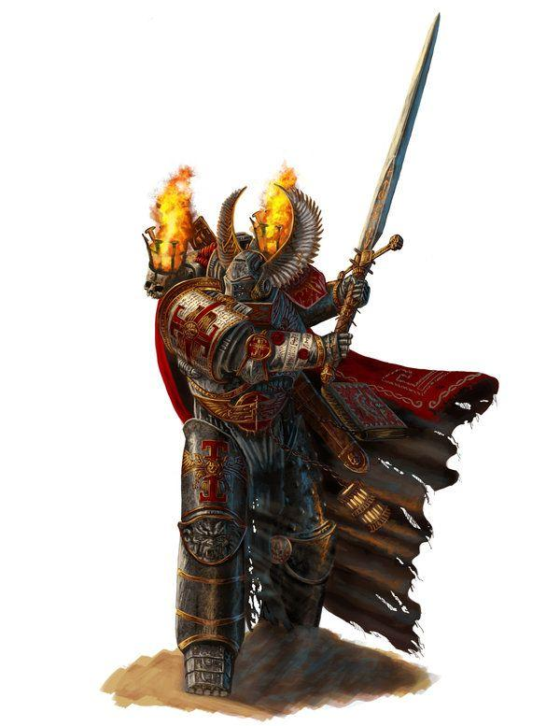

**Knight of the Order of the Grey:**

prerequisites: must complete a psychological horror adventure alone designed by DM.

pass 20 consecutive survival checks. die if a single is failed

find an unmarked empyrean of a magic god or a greater spellcaster and look into their arcane soul and mark them.

10 total witch hunter/inquisitor/priest lord levels

cannot choose to be initiated instead is chosen.

loses all memories and personality after success, new existence is the antithesis to their marked one.

**Hit points**

Hit Dice: 1d20 per witch hunter level

Hit Points at First Level: 20 + your Constitution modifier

Hit Points at Higher Levels: 1d20 (or 11) + your Constitution modifier per witch hunter level after 1st level

**Proficiencies**

Armor: all armor, shields

Weapons: all weapons

Tools: alchemy tools

Saving throws: wisdom, intelligence and constitution

Skills: arcana, choose 5 from: athletics, survival, intimidation, insight, perception, investigation

**Order of the Knights of Grey:**

|  |  |  |  |  |  |
| --- | --- | --- | --- | --- | --- |
| armor | cost | armor class | strength | stealth | weight |
| order of the grey platemail* | non-acquirable | 20 | 18 | disadvantage | 70 |
| order of the grey juggernaut armor** | non-acquirable | 24 | 20 | disadvantage | 80 |
| bonded shield*** | non-acquirable | 2 | - | - | 5 |

*reduce wearers speed by 5

**reduce wearers speed by 15

***increases AC by your order of the knights of the grey level divided by 3 rounded

up

|  |  |  |  |  |
| --- | --- | --- | --- | --- |
| Name | cost | damage | weight | properties |
| bonded weapon | x | determined by base weapon | x | this weapon gains a bonus to damage and hit rolls equal to your knights of the order of the grey level divided by 3 rounded up. |

|  |  |  |
| --- | --- | --- |
| level | proficiency bonus | features |
| 1st | + 4 | Knight of the Order of the Grey |
| 2nd | + 4 | words of the unarcane |
| 3rd | + 5 | order feature |
| 4th | + 5 | justicar |
| 5th | + 5 | improved words of the unarcane |
| 6th | + 5 | order feature |
| 7th | + 6 | brotherhood champion |
| 8th | + 6 | bastion of the soul and body |
| 9th | + 6 | order feature |
| 10th | + 6 | knight of the table |

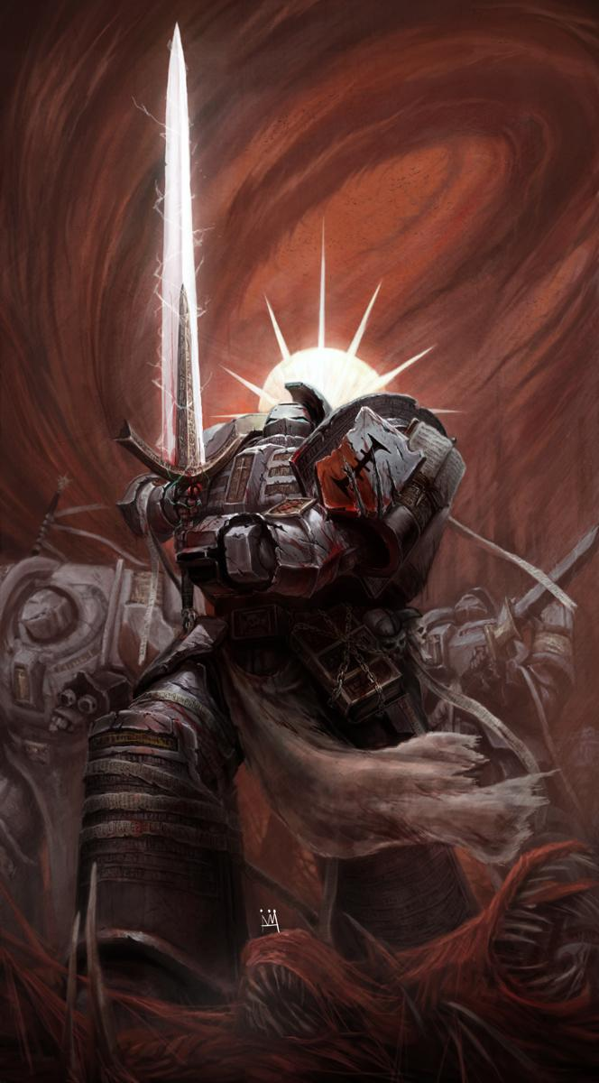

**Knights of the order of the grey**: count as having truesight against the creature you marked in your initiation. gain advantage on saving throws. all experience required to level up is multiplied by 10. this character now ages at 1/30th the speed of a normal mortal



**words of the unarcane:** you can spend a full action to gain truesight on a spellcaster within view for your next three turns.

**improved words of the unarcane:** you can spend a bonus action to gain truesight on spellcasters within view for the rest for the encounter.

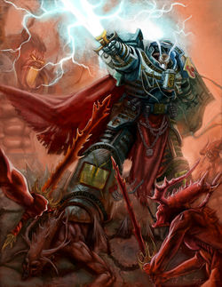

**Bastion of the soul and body:** your wisdom and constitution can now be increased to 25 by any means, increase both scores by 3.



**Justicar:** gain +10 on saving throws.

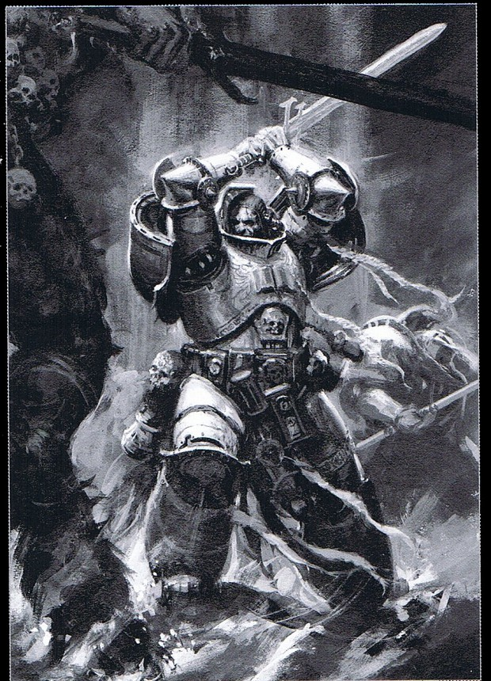

**Brotherhood Champion:** gain advantage on attack rolls.

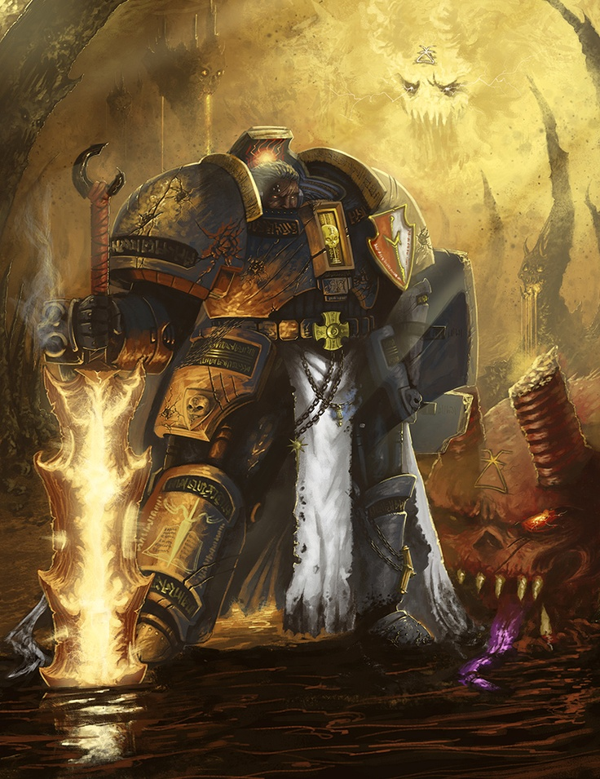

**Knight of the Table:** rolling a 16-20 now counts a critical success.

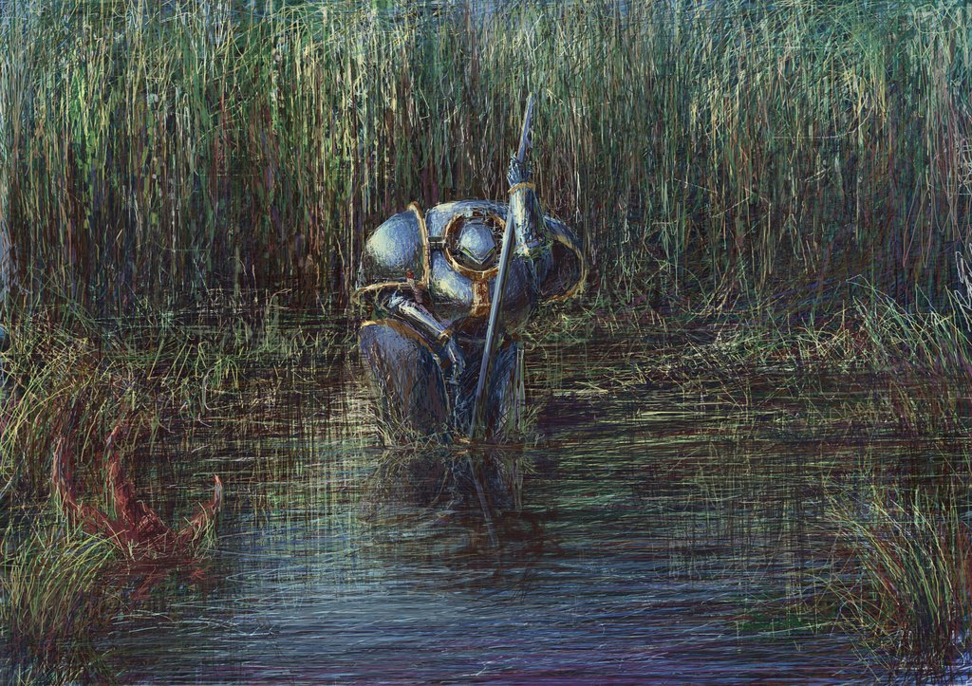

**Order Specialization**

At 3rd level choose an archetype, purifier cleans the world with fire, juggernaut indomitable warriors that utilize teleportation due to their limited mobility, and knight errants knights of the order that disguise themselves as normal knights in order to discreetly locate the enemy and achieve great acts of valor.

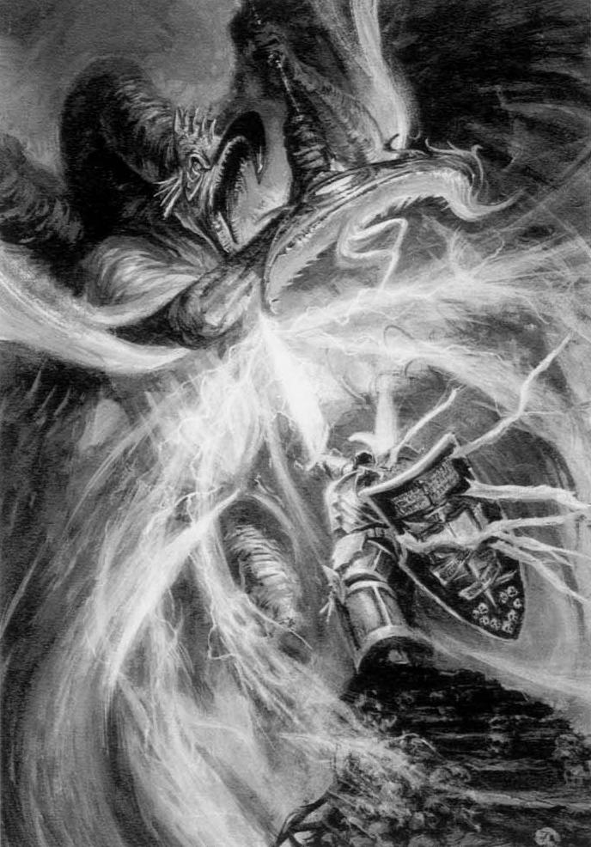

**Purifier:**

The specialization Purifier are Knights of the Order who passed all trial but were driven mad, they utilize the ability to summon fire through some antimagical means unbenounced to sane members of the order, most are insane like rabid dogs and must be bound and caged in between battles.

**Fire incarnate:** at 3rd level gain, all damage dealt by this character now counts as fire damage and is increased by 1d4. this character can manipulate fire around them at will. gain order of the knights of the grey platemail and a bonded weapon

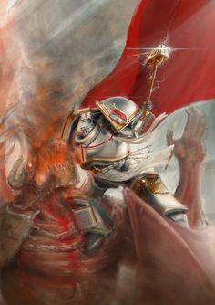

**Demon to Demons:** all spellcaster within the presence of this character must immediately make a wisdom saving throw against this character's wisdom score, if they fail they are in fear, each minute they may make a save against this character's wisdom score, each time they fail double the save check requirement.

**Pyromaniac:** enemies that enter or end a turn within 10ft of this character must succeed a wisdom saving throw against this character's wisdom or take 6d6 fire damage. fire damage dealt by this character cannot be reduced or avoided if a critical success was made by this character it cannot be negated in anyway.

**Knight Errant:**

The specialization Knight Errant are infiltrators and speedy combatants, preferring refined taste and finesse to straight up combat while still keeping their duties as hunters of the arcane. Those who choose this Specialization enjoy a certain degree of flexibility and political mindfulness while still being heavily armed and armored.

**Blend In:** gain proficiency in all skills, if you already have proficiency in a skill double your skill modifier for that skill. gain order of the knights of the grey platemail and a bonded shield and a bonded one handed weapon or a bonded two handed weapon.

**Quick and to the point:** can make attacks as bonus action. increase initiative by your proficiency bonus and then double it, increase your movement speed by 20.

**Determined:** three times per day you may choose to automatically critically succeed on any roll.

**Juggernaut:**

The Specialization Juggernaut is the absolute pinnacle of human endurance and strength, embodying the very will of the Order. Those who choose this archetype exchange maneuverability for tenacity, dexterity for strength, and damage for health.

**teleportation:** at 3rd level gain, you can cast misty step as a full action, and teleport as a full round. gain juggernaut armor, a bonded shield and a bonded weapon.

**improved teleportation:** at 6th level gain, you can cast misty step as a bonus action, and teleport as a full action. increase your maximum hit points by 3 times your level and an additional 3 whenever you gain a level in this class.

**advanced teleportation:** at 9th level gain, you can cast misty step at will, and teleport as a bonus action. your strength score may now be increased up to 30 by any means, increase your strength by 4.

**Ability Score Improvement**

When you reach 1st level, and again at 2nd,3rd,4th,5th,6th, 7th, 8th, 9th, and 10th level, you can increase one ability score of your choice by 2, or you can increase two ability scores of your choice by 1.As normal, you can't increase an ability score above 20 using this feature.

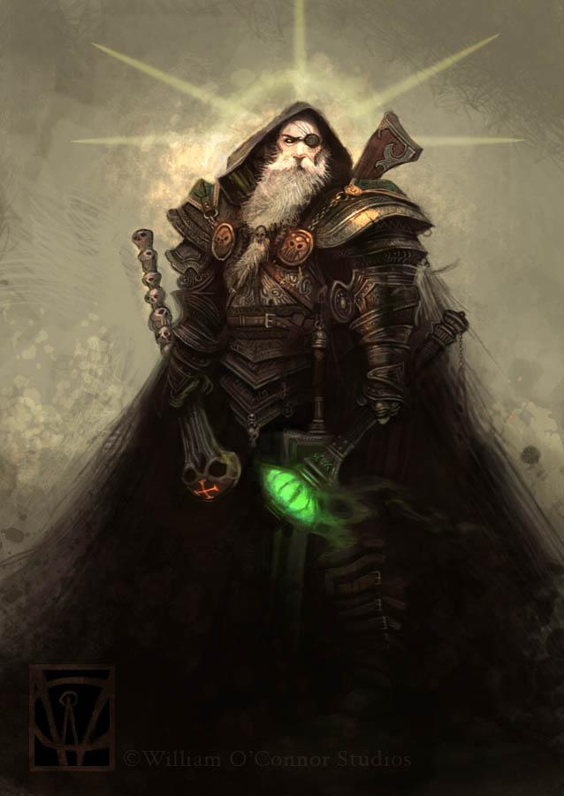

**Priest lord:**

prerequisites: must have at least ten levels in a nightswatch class and e chosen by a nightswatch priest lord

**Hit points**

Hit Dice: 1d4 per witch hunter level

Hit Points at First Level: 4 + your Constitution modifier

Hit Points at Higher Levels: 1d4 (or 3) + your Constitution modifier per witch hunter level after 1st level

**Proficiencies**

Weapons: staves

Saving throws: wisdom, intelligence and charisma

Skills: arcana, choose 5 from: deception, history, insight, intimidation, investigation, medicine, nature, perception, performance, persuasion, religion, sleight of hand, and stealth

|  |  |  |
| --- | --- | --- |
| level | proficiency bonus | features |
| 1st | + 4 | Authoritative word |
| 2nd | + 4 | Secrets of the keep |
| 3rd | + 5 | Antimagic declaration |
| 4th | + 5 | Secrets of the keep |
| 5th | + 5 | purification |
| 6th | + 5 | Secrets of the keep |
| 7th | + 6 | Improved antimagic declaration |
| 8th | + 6 |  |
| 9th | + 6 | Secrets of the keep |
| 10th | + 6 | Word of the emperor |

**Authoritative word**: gain advantage on persuasion checks

Antimagic declaration: once per encounter you may cast counterspell as a free action with your wisdom as the spell save dc

Purification: gain one of the following

* you always pass wisdom saving throws if you can see their source
* at the beginning of your turn you gain temporary hit points equal to your level in this class
* when you deal damage to a magic user double that damage

improved antimagic declaration: you can now cast counterspell up to three times per encounter and your wisdom save dc is increased by your proficiency bonus

word of the emperor: spells cast within 60 ft of you cost twice as many spell slots to cast

Secrets of the keep: every time you gain secrets of the keep you gain one of the following abilities

* you gain truesight 60 ft while inside the keep or castle you rule in
* cantrips cast in your keep or castle require a first level spell slot to be cast
* living creatures in your keep have advantage on saving throws against spells
* magical creatures inside your keep halve their speed
* if a spell is cast within your keep if it fails to effect its target it instead targets its caster
* if you are reduced to 0 or less hit points you are instead reduced to 1 hit point, you may use this ability a number of times equal to your proficiency bonus between short or long rests.



**Warborn**

The warborn are individuals whose souls don't know the limits of others, they push their bodies to the extremes often times damaging themselves, as this ability comes from the sheer fact that warborn have a limited perception of pain and limits.

Prerequisites:

This must be your starting class or the dm must say it is okay for you to take levels in this class

**Hit Points**

**Hit Dice:** 1d12 per warborn level

**Hit points at 1st Level:** 12 + your Constitution modifier

**Hit points at Higher Levels:** 1d12 (or 7) + your Constitution modifier per maleficus level after 1st

**Proficiencies**

**Armor:** all armor

**Weapons:** all weapons

**Tools:** none

**Saving Throws:** Constitution

**Skills:** Choose two from acrobatics, Athletics,

Insight, Perception, and Survival

|  |  |  |
| --- | --- | --- |
| level | War points | features |
| 1 | 1 | Warpath, warpoints |
| 2 | 1 | - |
| 3 | 1 | - |
| 4 | 1 | Ability score improvement |
| 5 | 2 | Warpath feature |
| 6 | 2 | Ability score improvement |
| 7 | 2 | - |
| 8 | 3 | Ability score improvement |
| 9 | 3 | - |
| 10 | 4 | Ability score improvement |
| 11 | 5 | Warpath feature |
| 12 | 7 | Ability score improvement |
| 13 | 8 | - |
| 14 | 8 | Ability score improvement |
| 15 | 10 | Warpath feature |
| 16 | 11 | Ability score improvement |
| 17 | 12 | - |
| 18 | 13 | Ability score improvement |
| 19 | 14 | Ability score improvement |
| 20 | 16 | Warmachine |

**1st War points:**

When a war point is spent make an ability check, add your half your maximum warpoints to this roll, also subtract the amount of war points you spent to make this check. If you fail this roll gain a level of exhaustion

**20th Warmachine**: when this character's level of exhaustion increase roll a die, on evens instead your exhaustion level is reduced by one, when this character spends war points roll a die, on evens instead add one to your current war points this cannot not exceed your maximum war points.

**1st Warpaths**: there are two types of warborn, those who were born to destroy and those who were born to distract.

**Distractors**

**1**: you gain proficiency in dexterity saving throws, and you gain one of the following abilities:

* Spend one war point: until the end of your next turn you have +5 to ac, and +7 to initiative
* Spend two war points: whenever you provoke opportunity attacks this encounter enemy creatures must make them, if they do they must skip there next turn.
* Spend one war point: for the next 10 minutes increase your dexterity by 5

**5**: you can add the higher of your dexterity or constitution modifiers to war point checks

**11**: enemies that can target you with attacks but choose to target other creatures have disadvantage on their attack rolls

**15**: you gain one of the following abilities, and an additional one from level one of the destroyer warpath.:

* Spend two war points: you may choose to succeed on your next attack, if the warpoint check for this ability was a critical success you automatically critical hit
* Spend four war points: during this encounter you have flying speed equal to double your normal speed, if the warpoint check for this ability was a critical success you also gain truesight 30 for this period of time.
* Spend eight war point: you gain 3 extra full actions during your turn, if the warpoint check for this ability was a critical success you gain an additional 6 full actions

**Destroyers**

**1**: you gain proficiency in strength saving throws, and you gain one of the following abilities:

* Spend one war point: your next attack has +5 to hit, and +7 to damage
* Spend two war points: all your attacks this encounter have +1 to hit and +2 to damage
* Spend one war point: for the next 10 minutes increase your strength by 5

**5**:you can add the higher of your strength or constitution modifiers to war point checks

**11**: if you would be reduced to 0 or less hit points instead you are reduced to 1, you can use this ability once in between short rests, every time you kill a creature or make a critical hit you gain an additional charge for this ability until the end of the encounter.

**15**:you gain one of the following abilities:

* Spend one war point: your next attack has -5 to hit, and +14 to damage if the warpoint check for this ability was a critical success your attack instead gets -3 to hit and +12 to damage
* Spend three war points: regain 1d12 hit points at the beginning of each of your turns this encounter, if the warpoint check for this ability was a critical success you may choose to gain 7 instead of your roll after rolling. If you would take a critical hit you do not regain any more hit points this way for the rest of the encounter.
* Spend seven war point: for the next 10 minutes double your strength, if the warpoint check for this ability was a critical success double your constitution as well

**Rules:**

**Initiative**: each creature's initiative is calculated at the beginning of the round based on the actions they choose to make and their equipment. Each creature adds there dexterity modifier to the following applicable modifiers, if there is a tie then both creatures activate simultaneously.

|  |  |
| --- | --- |
| Status | modifier |
| Light armor | +6 |
| Heavy armor | -6 |
| Shield | -3 |
| Light weapon | +3 |
| Heavy weapon | -3 |
| Weapon with reach and the target is within 5 ft | -3 |
| Weapon with reach and the target is not within 5 ft | +3 |
| Exotic weapon | -3 |
| Not proficient with weapon | -6 |
| Not proficient with armor | -6 |
| Item is master crafted | +mastercraft level |
| Item is magical | +magic bonus |
| small | +4 |
| medium | +2 |
| large | -2 |
| tiny | +6 |
| huge | -4 |
| gargantuan | -6 |
| Two handed weapon | -3 |
| One hand versatile weapon | -2 |
| Two hand versatile weapon | +2 |
| Bludgeoning damage | -2 |
| Piercing damage | +2 |
| Additional attack | -3 |
| spell | -3 |
| cantrip | +2 |

**Stances:** during combat at the beginning of your turn you choose one of five stances, parry swordplay, strike, smash, or dodge. If your stance is directly clockwise of your opponent's stance you get a 4 to hit and if it is within 3 and not 1 you get a 2 to hit otherwise you get a 0, add the appropriate ability score + 1d4 + 1/5th of ac rounded up (the d4 technically counts as ad20 for advantage, disadvantage and other modifiers). Compare your hit chance to your opponent's block chance which is calculated the same way, whoever is higher wins, if the attacker wins their attack hits if the blocker wins the attack does not hit. If you are not proficient with your weapon the only attack you can use is smash. Whenever you take an action you may choose a new stance, your stance stays the same until the next time you change it. If there’s a tie the attacker wins

At first level you can only use smash, every time you can take an ability score improvement you may choose to learn a new stance.

|  |  |
| --- | --- |
| name | Damage modifier |
| smash | +3 |
| strike | +2 |
| dodge | -1 |
| parry | -2 |
| swordplay | +1 |

Enchantments

You can enchant an object or living thing by selecting a transmutation or enchantment spell. Then cast the following spell: enchantment, level 4 + level of selected spell(if this exceeds nine then make it nine and a sentient sacrifice with an intelligence modifier equal to or greater than the difference), effect: the spell chosen takes effect on the target and its effects duration is the lifespan of the target.

**Background**

* The background Doctor is available, since the Lightfall disease has been rampant throughout the land, doctors have risen to tend to those who need it, whether this be in a hospital, or the battlefield. Skill proficiencies: medicine, perception. Tool proficiencies: Alchemist tools, medic pack. Equipment: a pouch of herbs and ointments, a gas mask, a heavy leather cloak and gloves, a medical book, and a belt pouch containing 10 gold

**RACES:**

**Sourbloods:**

**Born of Death**

Sourbloods take on the appearance of their father race. Sourbloods born of elves are tall and graceful, and sourbloods born of humans are more stout and heavy set.

Sourbloods often will live for over 100 years, with the oldest being 147 years of age before he was slain. They reach maturity at the same time as human. This gives them a more human perception of time, wishing to make the most of their unfortunate fates.

**Outcasts**

Sourbloods often find it difficult to live among mortals, as most see sourbloods as abominations, unnatural. It is not unheard of, though, for a sourblood to find peace within a village or even a city. More rare is a sourblood being accepted by vampires. If mortals see sourbloods as abominations, vampires view them as sin incarnate. Only in legends has the story of a sourblood serving vampires ever been recalled.

**Sourblood Names**

Once old enough to sustain themselves, sourbloods often take up a common name from their fathers’ race. Until that time, they are often named for the first word they say or, before that, simply ‘sourblood’.

**Sourblood Traits**

***Ability Score Increase.*** Your Dexterity and Strength scores are increased by 1 each. You also get an extra point to put in any score.

***Age.*** Sourbloods reach peak maturity at the same time as humans, around 17, and often live for over a century.

***Alignment.*** Sourbloods are often twisted by the hateful words of other mortals. In defiance to the mothers that birthed them, sourbloods will usually stray from law. They also learn to fend for themselves and worry about the repercussions to others later, abandoning good for a more neutral or evil approach to life.

***Size.*** Sourbloods most closely resemble their fathers in appearance. Your size is Medium.

***Speed.*** Inheriting some of your mother’s speed, your base walking speed is 35 ft.

***Vampire’s Darkvision.*** Another gift from your mother, you have amazing vision in dark and dim conditions. You can see in dim light and darkness within 60 ft of you as if it were bright light.

**_ *Vampiric Ancestry.*** Yet another gift of your vampiric heritage, you can transform into a creature of the night and siphon the life energy from mortals.

For an hour each day, you can transform into either a bat, a rat, or a wolf. To do this, you must recite an incantation, which takes five minutes, and then roll 2d6. On a 5, 6, 7, 8, or 9, you become a bat; on a 3, 4, 10, or 11, you become a rat; and on a 2 or 12, you become a wolf. At 7th level, you don’t need to recite an incantation and at 14th level you can choose which animal you become.

To siphon life you can make an attack against any willing, restrained, incapacitated, or grappled (by you) mortal, dealing 1d4+[STR Mod] piercing damage plus 1d6 necrotic damage for every three of your levels. You regain hit points equal to half the necrotic damage dealt.

***Languages.*** You can read, speak, and write Common. Some sourbloods raised by elves or half-elves can read, speak, and write Elven, but most don’t have that luxury. Ask your DM if you can know this language.



kithkin

**ability score increases**: +2 to dex, +1 to constitution

**age**: adolescent kithkin range from 5-10 years old, adults are 11-40, elders are 41-60, 61-100 are very old

**alignment**: always lawful, and good neutral or evil based on their bonds.

**size**: average 3’ 8” and 152 lbs

**speed**: your speed is 30 feet

**by day by night**: during day happy and optimistic, during night grimm and paranoid

**telepathic**: at lvl 1 have empathic capabilities towards friendly kithkin, by lvl 20 complete telepathic communications with all kithkins, essentially an ethereal mind inhabiting the thoughtweft using the body as a vessel to reality.

Shrewd: gain advantage on insight checks during battle to determine the choices an enemy will make.

Hardy: gain advantage on death saving throws while not in combat.

Kithkin magics: you may take the kithkin magic feat [ you gain surge of thoughtweft spell at 2nd level, and champion of thoughtweft at 10th level]

|  |  |  |  |  |
| --- | --- | --- | --- | --- |
|  | base height | multiplier | base weight | multiplier |
|  | 2' 9" | 2d12 | 75 lb | 2d4 |
| average | 3' 10" |  | 140 lb |  |
| max | 4' 9" |  | 267 lb |  |
| min | 2' 11" |  | 79 lb |  |
| range | 2’ |  | 188 lb |  |

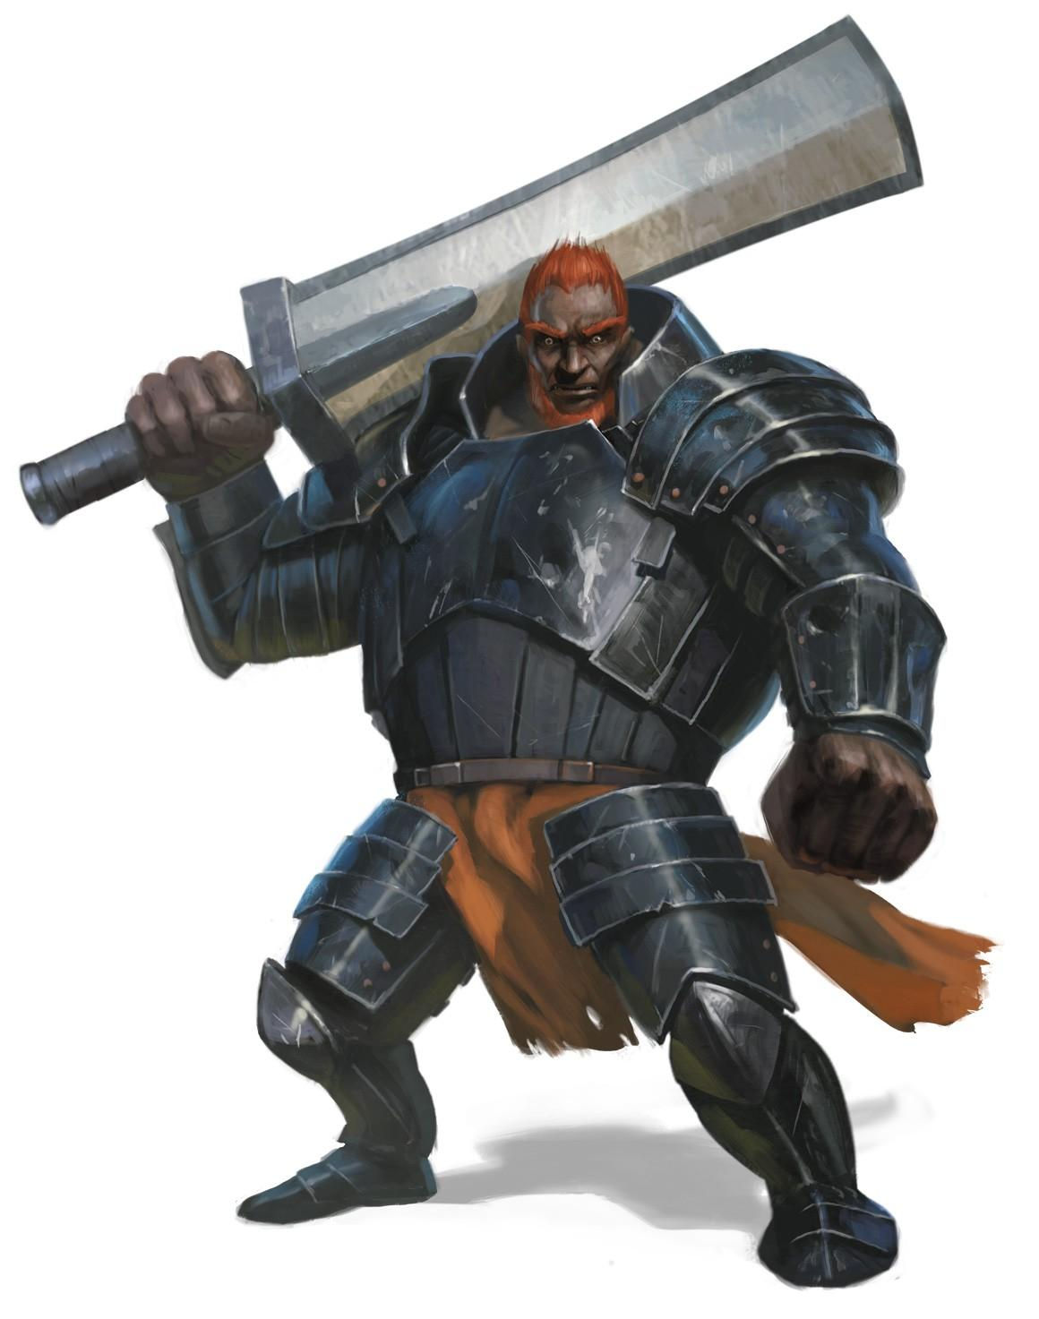

Smalls

**ability score increases**: +2 to strength, +2 to constitution

**age**: considered adult at the age of about 100, but can live to be over 800 years old

**alignment**: always lawful.

**size**: average 6’ and 400 lbs

**speed**: your speed is 25 feet

Culture of war: gain the weapon master and leadership feat, you are also proficient with smiths, carpenters, wood carvers, leatherworkers and cobblers tools.

Fire resistance: gain resistance to fire damage

|  |  |  |  |  |
| --- | --- | --- | --- | --- |
|  | base height | multiplier | base weight | multiplier |
|  | 5’ 7” | 2d4 | 375lb | 2d4 |
| average | 6’ |  | 400 lb |  |
| max | 5' 9” |  | 439 lb |  |
| min | 6' 3" |  | 379 lb |  |
| range | 8” |  | 60 lb |  |

Dwarc, very tough and strong dwarc are squat greyish thick haired humanoids. there faces are very angular and square with small beady eyes and enlarged canines with broad noses. base height: 4’ 5” height modifier: 2d6 base weight: 135 weight modifier: 2d6

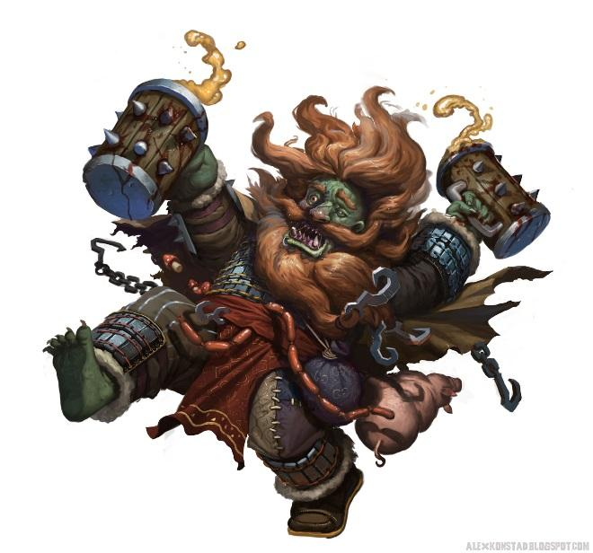

**Dwarc:**

**Born of War** born to fight dwarcs have little regard for their own life and will often run headstrong into battle

**Slaves** dwarc are born into slavery and only escape if they’re caught in caravans that are destroyed or other obscure events of the like.

**Dwarc Names** often given brutish sounding dwarvish names with grotesque orc clan names dwarcs have a hard time describing their own names to more civilized folks.

**Dwarc traits Traits**

***Ability Score Increase.*** You gain +1 to dexterity, strength, constitution, and wisdom.

***Age.*** Reaches maturity at age 13 and can live to be up to 200, usually die due to fighting in their early twenties.

***Alignment.*** Always chaotic, never neutral

***Size.*** medium

***Speed.*** 25

***Warblood:*** *gain advantage on perception checks*

***Languages.*** *Orcish and dwarvish.*

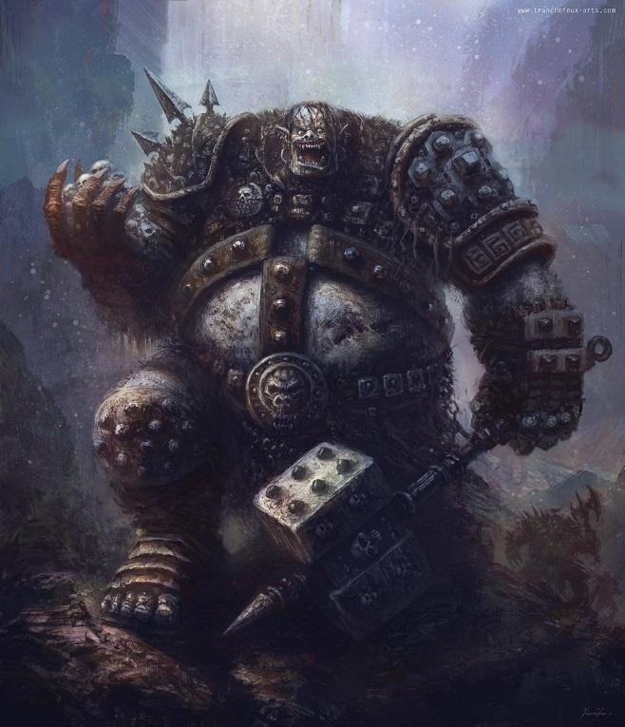

**Orcen**, ancient advanced orcs naturally gifted arcanists with a preference for the dark

**Warlock lords**: a race of warlords from the underdark, orcen made deals with devilish powers to empower themselves and conquer the races around them.

**Arcanists** orcen are naturally gifted in the arcane due to their pact with the infernals.

**Infernal:** due to their long standing pact with the infernal lords the orcen are often born with traits of their pact lords some examples include producing slime from baalzebul, extreme beauty from glasya, skin that is cold to the touch from levistus, pale grey skin from fierna and belial, scales from mammon, one or more sets of horns and red skin from asmodeus, complete lack of emotions from dispator, hulking size and seething muscles from bel, and an aura of shadows from mephistopheles

**orcen Names** names given to orcen are similar to that of orcs but their clan names are oftentimes named after the devil that granted their ancestors power

**orcen traits Traits**

***Ability Score Increase.*** You gain +2 to intelligences and +1 to charisma

***Age.*** Reaches maturity at age 20 and can live to be up to 140 or so.

***Alignment.*** Always lawful

***Size.*** medium

***Speed.*** 30

***Devil pact:***

*Baalzebul: can cast grease at will, once grease is cast any previously cast grease disappears.*

*Glasya: gain advantage on casting rolls for spells that charm their targets*

*Levistus: gain the cantrip ray of frost, charisma is your spellcasting modifier*

*Fierna & belial: you can cast any cantrip as a bonus action, if you cast a second or more cantrip this way during your turn you cannot add your proficiency bonus to the cantrips bonus or dc*

*Mammon: you can cast minor illusion only to create forms of coins.*

*Asmodeus: add fire bolt to your spell list*

*Dispator: you can cast friends at will once per hour, your spell casting ability for this is intelligence*

*Mephistopheles: when you cast ray of frost you can cast fire bolt as a free action, when you cast fire bolt you can cast ray of frost as a free action*

*Bel: increase your strength by 2*

***Languages.*** *Infernal, broken common, and orcish*

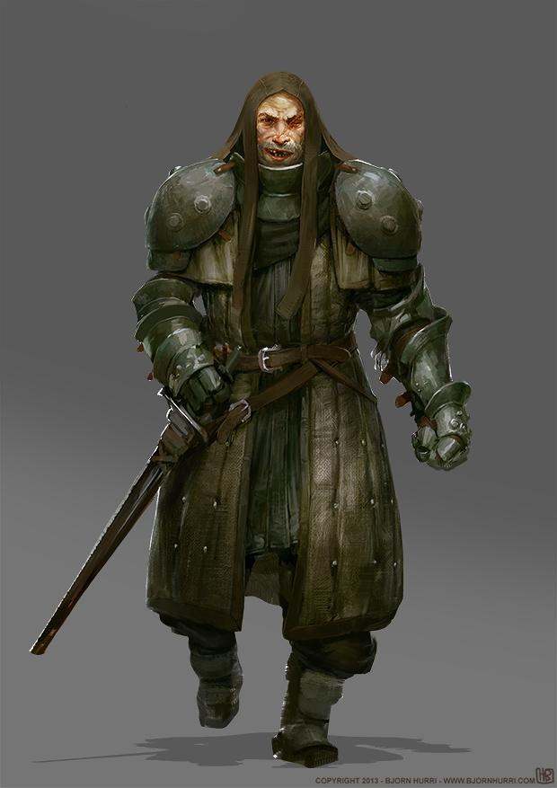

Meidken, the half souls, each born with a familiar that completes their souls

**Broken spirit:** the meidken were a race of men who existed in a place of constant danger and a requirement of wariness was always prevalent, eventually their mages figured a way break their soul into pieces to create a second pair of eyes for each person, a watch dog they were born with.

**Mutts:** due to their long time exposure to war and conflict the meidken interbred with many races, although they do have a significant intolerances for those races they view as innately magical

**Meidken Names** meidken are often given names similar to humans while their familiars often take their family names.

**meidken traits Traits**

***Ability Score Increase.*** You gain +2 to wisdom and +1 to dexterity

***Age.*** Reaches maturity at age 12 and can live to be up to 80 or so.

***Alignment.*** Any alignment

***Size.*** medium

***Speed.*** 30

***Broken soul:***

*You can cast find familiar at will and you gain one of the following effects:*

* *Your familiar is indestructible*
* *Your familiar can deal 1d6 damage as a natural attack each turn*
* *Your familiar grants you proficiency in dexterity saving throws and perception*

***Languages.*** *Common, and dwarvish or halfling*

*Dwarf subraces:*

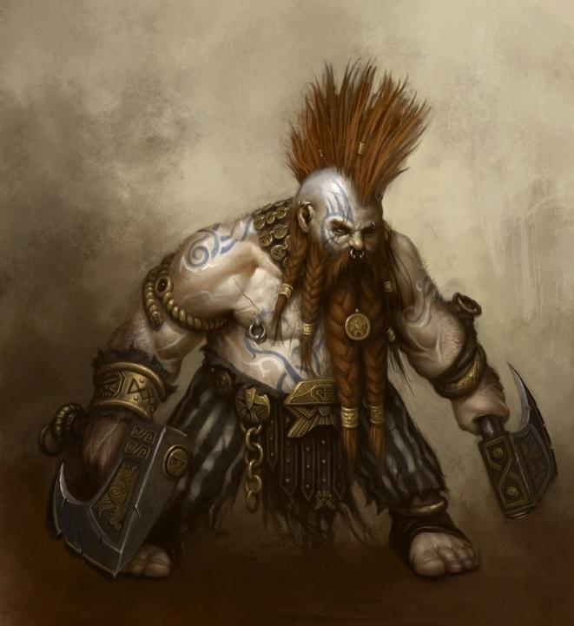

*The Kran: the kran are large robust dwarves capable of marvelous feats of strength and are often dimwitted and idiotic, they are native to jungles. They range from 3 to 5 ft tall and 150 to 300 lbs. Most kran sport large pointy hairstyles such as mohawks and long unkempt beards, kran dye their hair bright orange with crushed up jungle insects.*

*Massive strength: increase this character's strength by 3*



*The shameful ones: the shameful ones are the offspring of fire giants and dwarves, they are shunned by both of their parents society's due to their origin.*

*Size: this character's size is medium*

*Height and weight: shameful ones usually span between 7 and 9 ft tall and weigh between 700 and 900 lbs*

*Ability score increases: +1 strength*

*Sturdy frame: this character may forgo taking a normal attack to make an unarmed attack with both hands if they are both free, this attack has advantage if the targets size is large or greater. This attack does damage equal to xd4 and the target is grappled, where x is your level.*

*Tough hide: this character's armor class while not wearing armor is 14 + their constitution modifier and this character has resistance to fire damage*



*Sky dwarves: sky dwarves are spawned from the hammer of moradin, due to their position floating above the material plane sky dwarves believe themselves above almost all other races with few exceptions. Sky dwarves have light blue skin dark blue hair and bright yellow eyes and are often lankier than other dwarves.*

*High breeding: this character gains advantage on charisma intelligence and wisdom saving throws against non dwarvish creatures as long as they are not frightened.*

*Hammer forged: once per day this character may summon an astral hammer for one minute, at the beginning of each of their turns they gain temporary hit points equal to their level and when this ability is activated whatever is in your dominant hand disappears into the astral plane and is replaced with a ghostly hammer that gets a bonus to hit equal to your level divided by 7 rounded up and deals a number of d4 damage equal to your level*

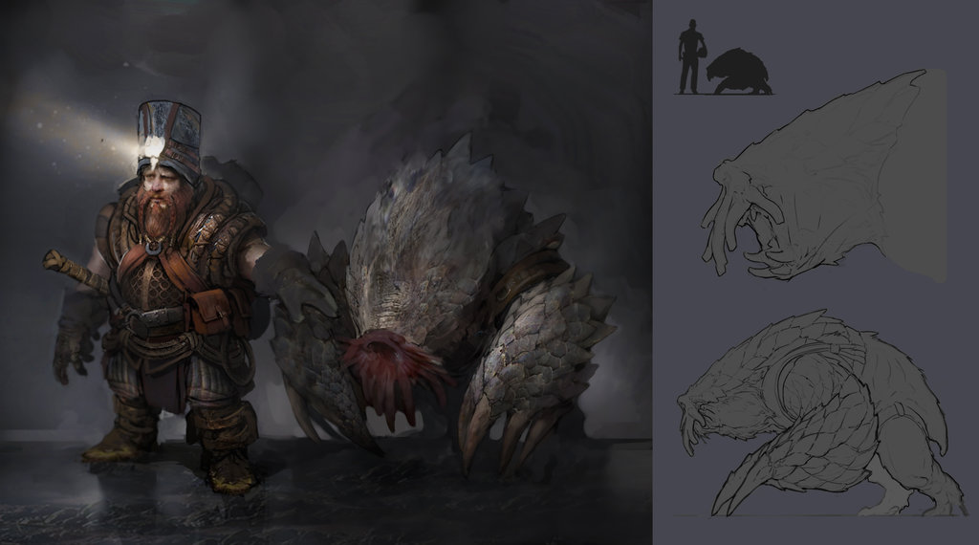

*Depth diggers: depth diggers are short even for dwarves and have hands that droop down to their feet, this enables them to dig so fast that they appear to swim through dirt.*

*dirt swimming: you can dig at your walking speed*

*digging hide: you have damage reduction 1*

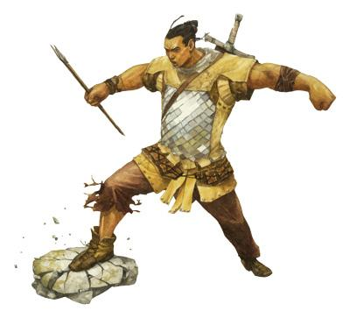

**Half Giants:** The offspring of Giants and Humans.

**Character Traits:**

**Age:** Half Giants can live up to 200 years old

**Ability Score increase:** +2 strength and constitution

**Speed:** 20

**Giants Resistance:** When you create a Half Giant, choose resistance to bludgeoning, fire, radiant or thunder and lightning. You become a Giant of that respective damage type.

**Alignment:** All Alignments

**Size:** Large

**Language:** Giant and Human



**Half Dwarf:** Half Human, Half Dwarf

**Age:**

**Ability Score increase:** +2 Constitution and Wisdom

**Speed:** 25

**Dwarven Expertise:** Gain proficiency with any kit

**Dwarven Coolness:** When rolling hit die to regain health, roll a die one size larger than your hit die

**Alignment:** All Alignments

**Size:** Medium

**Language:** Human and Dwarven



**Giant Elf:** A combination between an Elf and Giants

**Age:** Giant Elves live to be between 200-250 years old

**Language:** Giant and Elvish

**Ability Score:** +2 Constitution and Intelligence

**Sapling Camo**: You can spend an action to conceal yourself as a sapling

**Mildly Telepathic:** You have mild telepathic abilities

**Size:** Large

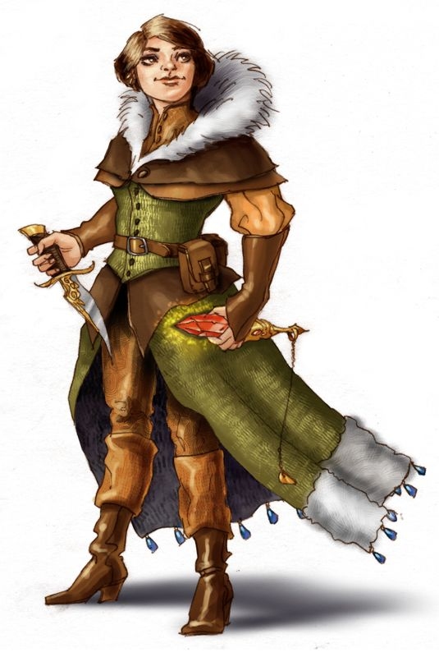

**Quarterling:** the offspring of a human and a halfling

**Age:** quarterling live to be between 80-120 years old

**Language:** halfling and Elvish

**Ability Score:** +2 dexterity and wisdom

**perceptive**: You have advantage on stealth checks made completely against an enemy's auditory capabilities

**lucky:** You have advantage on death saving throws

**Size:** small

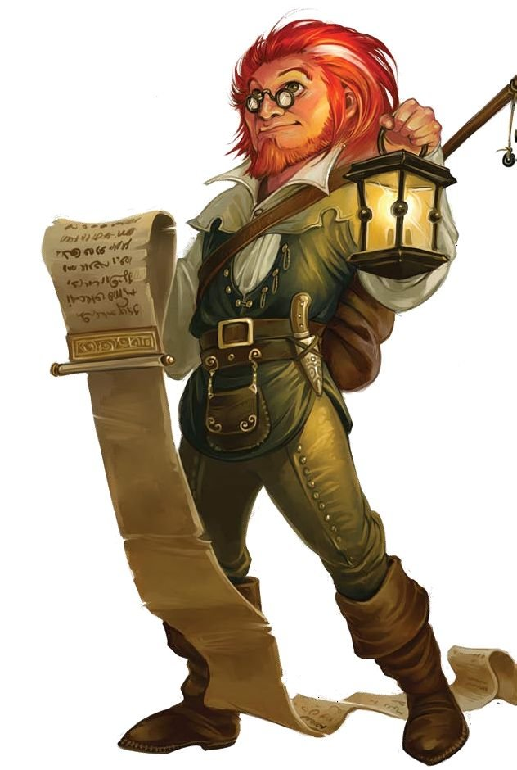

**half gnome:** A combination between an humans and gnomes

**Age:** half gnomes live to be between 170-230 years old

**Language:** common and Elvish

**Ability Score:** +2 dexterity and Intelligence

**inspiring intellect**: gain proficiency in intelligence saving throws

**ingenuity:** whenever you gain a feat increase your intelligence by 1

**Size:** medium



**sylvari:** sentient plants

**Age:** sylvari live to be between 500-750 years old

**Language:** Giant and Elvish

**Ability Score:** +2 Constitution and Intelligence

**growth**: you may spend hit dice as bonus actions while in sunlight and fresh water.

**barkskin:** at the start of your turn if you have less temporary hit points than your level gain temporary hit points equal to your level.

**Size:** choose between medium and small



**gatoran:** a humanoid alligator

**Age:** gatoran live to be between 50 - 80 years old

**Language:** common

**Ability Score:** +2 Constitution and strength

**snapper**: as a bonus action on your turn if you are not wearing a helmet you may make a bite attack. a bite attack gets -3 to hit but does 1d10 + 3 + str mod damage.

**strong tail:** you have a swim speed of 45 ft

**Size:** medium

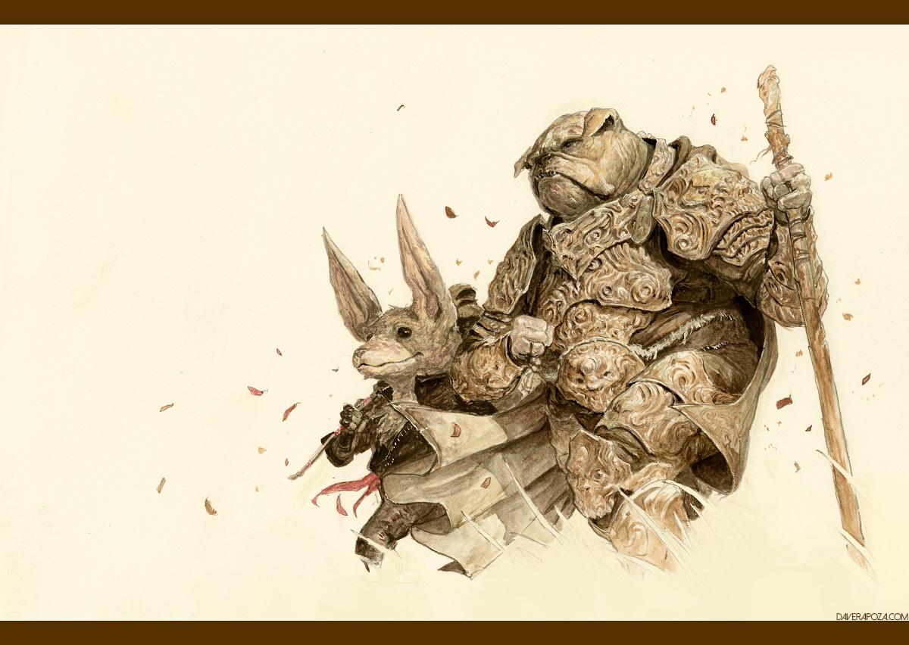

**Mongrel:** gnome height humanoid hunchback canines

**Age:** mongrels live to be between 20-25 years old

**Language:** common

**Ability Score:** +2 dexterity and constitution

**speed:** 40

**heightened senses**: double your proficiency bonus

**bite attack:** you may forgo your attack during your turn to make a bite attack, this is an unarmed attack but if you hit with it during your previous turn you can choose to automatically hit the previous target with it

**Size:** medium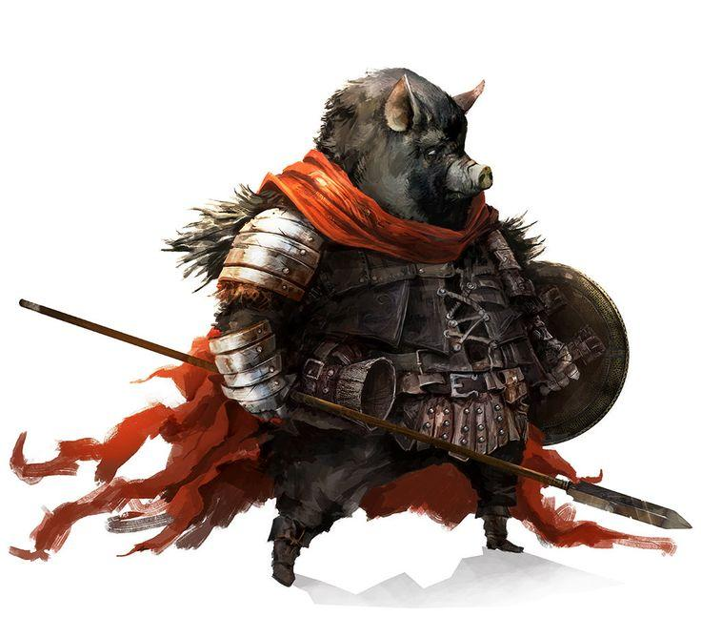

**Porker:** variable sized hog men

**Age:** porkers live to be between 300-400 years old

**Language:** common

**Ability Score:** +2 intelligence and constitution

**speed:** 25

**meaty**: you have resistance to bludgeoning damage

**highly intellectual:** you gain proficiency in intelligence saving throws

**Size:** medium

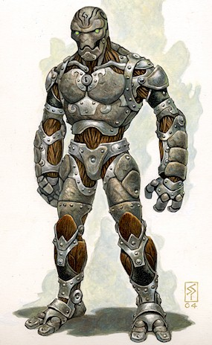

**Peaceborn:** the sister race to warforged peaceborn were created to populate the desolate mage collective society.

**Age:** peaceborn cannot die of old age

**Language:** common

**Ability Score:** +1 intelligence, charisma, and wisdom

**speed:** 30

**replication**: you can use the resources from the corpse of a humanoid creature and an equal amount of scrap metal to create a new peaceborn of a period of time equal to 10 days subtract your intelligence modifier.

**intuitive inventors:** you have advantage on intelligence checks to create or discover something

**Size:** medium



**Echtan:** stocky white bald humanoids

**Age:** echtan live to be between 800 - 1000 years old

**Language:** common

**Ability Score:** +2 dexterity and intelligence

**speed:** 25

**elder crafters**: halve the time it takes you to craft items

**agile fingers:** you have proficiency in dexterity saving throws

**Size:** medium



**glormling:** gnome height humanoid hunchback canines

**Age:** glormling live to be between 90- 110 years old

**Language:** common

**Ability Score:** +2 strength and constitution

**speed:** 20

**far realm strength**: damage you deal ignores temporary hitpoints

**wings:** you have a flying speed of 15

**Size:** medium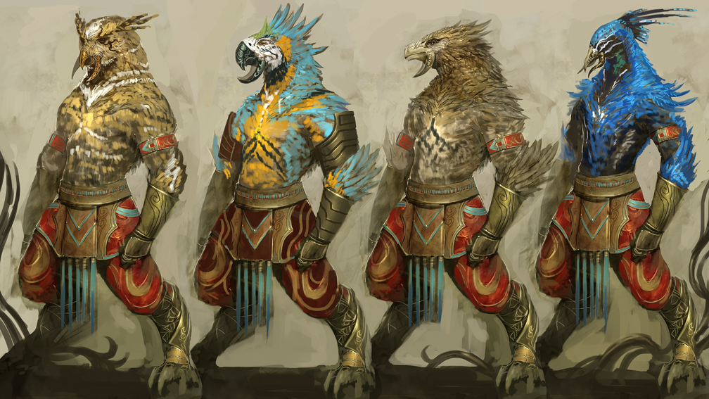

**qinqin:** gnome height humanoid covered in feathers, feathers and eye color can change at will and will shift with emotion

**Age:** qinqin live to be between 200-300 years old

**Language:** common and elvish

**Ability Score:** +2 dexterity and wisdom

**speed:** 35

**feathers**: you have flying speed 20

**color shifting:** characters have disadvantage on checks to recognize your character

**Size:** small



**torton:** large humanoid tortoises

**Age:** tortons live to be between 2000 - 3000 years old

**Language:** common and elvish

**Ability Score:** +2 wisdom and constitution

**speed:** 20

**shell**: you always count as wielding a shield

**knowledge with age:** you have proficiency in insight

**Size:** medium

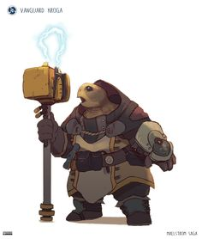



**sheliot:** above average height humanoidish crustaceans

**Age:** sheliot cannot die of old age

**Language:** common

**Ability Score:** +2 dexterity and constitution

**speed:** 30

**claw attack**: double all damage dealt by unarmed attacks

**shell:** you have resistance to slashing damage

**Size:** medium

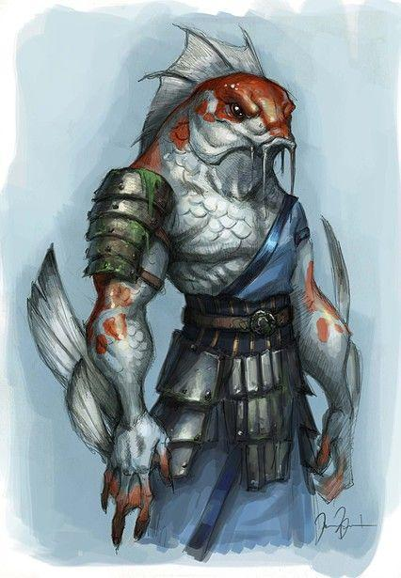

**blarblargs:** stocky amphibious humanoid fish men

**Age:** blarblargs live to be between 60-80 years old

**Language:** common

**Ability Score:** +2 dexterity and constitution

**speed:** 30

**gills**: you can breath underwater

**frightening visage:** you have advantage on intimidation checks

**Size:** medium



**turtlons:** large humanoid turtles

**Age:** turtlons live to be between 1000-2000 years old

**Language:** common

**Ability Score:** +2 dexterity and strength

**speed:** 25

**spiked shell**: enemies that make unarmed attacks against this creature take 1d4 + your proficiency bonus piercing damage

**patient:** this character has advantage on stealth checks to remain hidden in place

**Size:** medium



Prestige races: a prestige race is race that the player gains throughout their travels. This may seem counterintuitive as race is an inherent thing, but due to the experiments of mad scientists and cruel wizards race can change throughout one's lifespan.

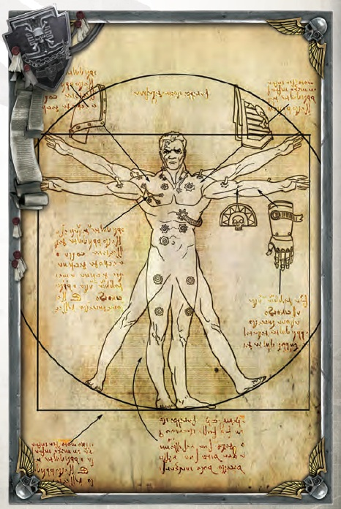

Titan: the titans are super knights created by the imperial scientists to bolster the war effort, though due to the intense resource cost of creating titans their chapters are few and far between.

Prerequisite: pass 5 survival checks, depending on how many are failed you remain the same and are horribly injured.

Benefits:

Ability score improvements: +2 dexterity, strength, constitution, intelligence, and charisma.

Lightning speed: increase speed by 10 ft, you may spend hit die as a free action, and you may spend an additional full action on each of your turns.

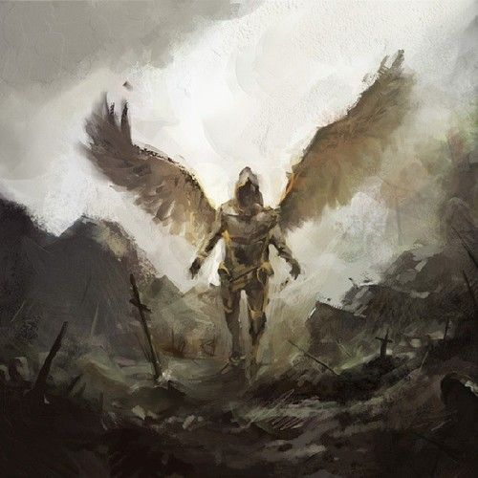

Blessed: the blessed are those chosen by a deity to provide and protect for the populace, they are generally revered as saints.

Prerequisite: perform a miracle

Benefits:

Ability score improvement: increase one ability score by up to 4

Divine power: when rolling for divine intervention quadruple your chances for it to occur.

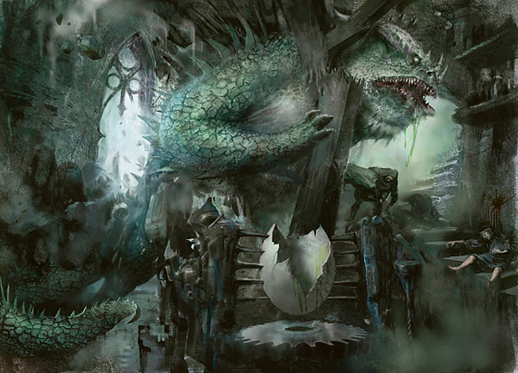

Abomination: abominations are creature s created by the mad scientists to see how far they can bring life how far they can stretch reality

Prerequisite: endure the experiments of a mad scientist

Benefits:

Transformation: when this character endures their experiments a trigger is implanted into them, whenever this character is triggered they transform for a dm determined amount of time. While transformed a character has two stats determined during their experiments increased to 30 for the duration of the transformation.

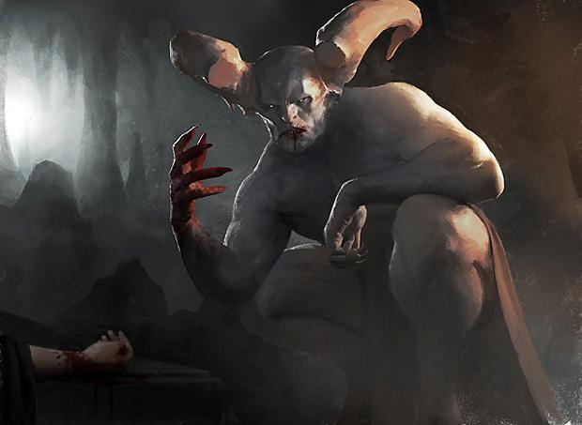

Possessed: possessed are those unfortunate few who let darkness into their soul and are met with a creature of pure evil, though they are bolstered in the material plane their soul is devoured to fuel this unholy power.

Prerequisite: have a demon or devil or other evil creature posses your soul willingly, then make a survival check, if you fail you die.

Benefits:

Ability score improvement: if your wisdom is less than 12 then it becomes 12, then increase all of your ability scores by your wisdom modifier

Demonic power: gain flying speed 30, and blindsense 5



Trollen: when troll regeneration mixed with a human supervirus created for the war the troll virus was created, it causes those afflicted to become very misshapen but they gain significant regenerative properties

Prerequisite: be afflicted with the troll virus, and don’t die

Benefits:

Ability score improvement: +3 constitution and strength

Regeneration: you can spend hit die as a bonus action, you gain an additional hit die at each level, your hit die size is one larger, you have advantage on rolls to regain health via a hit die.

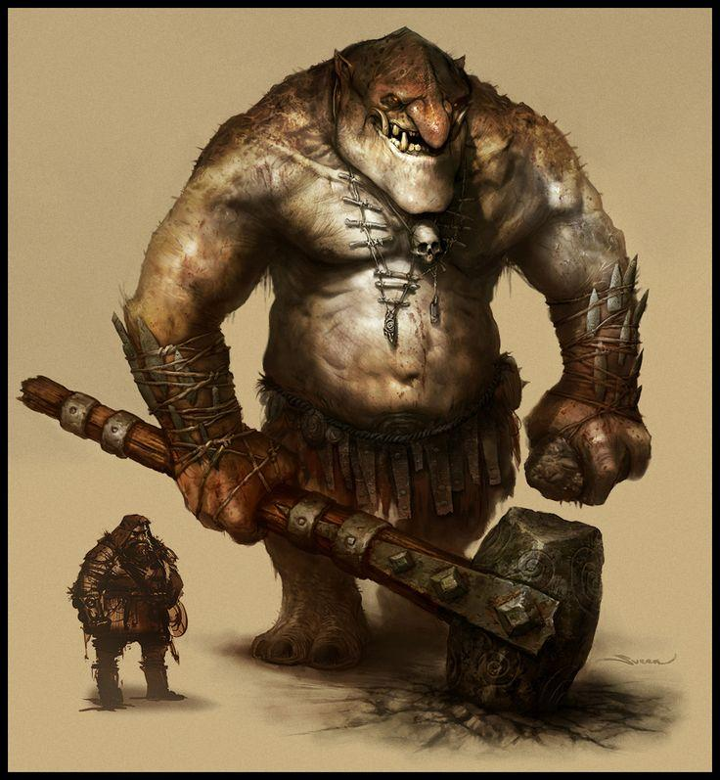



stitcher: creatures created from a living mind and the flesh of others to create a more powerful creature.

Prerequisite: the scientist creating you must make a sleight of hand check against your 30 - your constitution score or you die

Benefits:

Ability score improvement: increase one ability score of choice besides charisma and decrease charisma by 1

intrinsic weapons: your unarmed attacks deal an additional d4 damage

stitches: you can gain this race multiple times

Monsters:

Sylvan Frog

*Medium fey beast, unaligned*

Armor Class

12

Hit Points

16(4d8)

Speed

30 ft.

|  |  |  |  |  |  |
| --- | --- | --- | --- | --- | --- |
| STR  12 (+1) | DEX  14 (+2) | CON  10 (0) | INT  3 (-4) | WIS  11 (0) | CHA  2 (-4) |

Proficiency Bonus

+2

Skills

Perception +3, Stealth +4

Senses

darkvision 30 ft., passive Perception 13

Challenge

1/4(50 XP)

***Standing Leap.***The frog's long jump is up to 25 feet and its high jump is up to 15 feet, with or without a running start.

Actions

***Bite.***Melee Weapon Attack: +4 to hit, reach 5 ft., one target. Hit: 4 (1d8) piercing damage, and the target is grappled (escape DC 12). Until this grapple ends, the target is restrained, and the frog can't bite another target.

***Swallow.***The frog makes one bite attack against a small or smaller target it is grappling. If the attack hits, the target is swallowed, and the grapple ends. The swallowed target is blinded and restrained, it has total cover against attacks and other effects outside the frog and it takes 5 (3d4) acid damage at the start of each of the frog's turns. The frog can have only one target swallowed at a time. If the frog dies, a swallowed creature is no longer restrained by it and can escape from the corpse using 5 feet of movement, exiting prone.

Witches frog

*Medium fell beast, unaligned*

Armor Class

10

Hit Points

24(4d10)

Speed

30 ft., swim 30 ft.

|  |  |  |  |  |  |
| --- | --- | --- | --- | --- | --- |
| STR  11 (+0) | DEX  12 (+1) | CON  10 (0) | INT  4 (-3) | WIS  12 (+1) | CHA  5 (-3) |

Proficiency Bonus

+2

Skills

Perception +4, Stealth +2

Senses

darkvision 40 ft., passive Perception 14

Challenge

1/4(50 XP)

***Amphibious.***The frog can breathe air and water.

***Standing Leap.***The frog's long jump is up to 15 feet and its high jump is up to 5 feet, with or without a running start.

Actions

***Bite.***Melee Weapon Attack: +2 to hit, reach 5 ft., one target. Hit: 2 (1d4 - 1) piercing damage, and the target is grappled (escape DC 10). Until this grapple ends, the target is restrained, and the frog can't bite another target.

***Swallow.***The frog makes one bite attack against a small or smaller target it is grappling. If the attack hits, the target is swallowed, and the grapple ends. The swallowed target is blinded and restrained, it has total cover against attacks and other effects outside the frog and it takes 5 (3d6) acid damage at the start of each of the frog's turns. The frog can have only one target swallowed at a time. If the frog dies, a swallowed creature is no longer restrained by it and can escape from the corpse using 5 feet of movement, exiting prone.

Biter frog

*small beast, unaligned*

Armor Class

14

Hit Points

9(3d4)

Speed

20 ft., swim 10 ft. ft.

|  |  |  |  |  |  |
| --- | --- | --- | --- | --- | --- |
| STR  8 (-1) | DEX  9 (-1) | CON  8 (-1) | INT  2 (-4) | WIS  8 (-1) | CHA  4 (-3) |

Proficiency Bonus

+2

Skills

Perception +2, Stealth +6

Senses

darkvision 10 ft., passive Perception 12

Challenge

1/8(10 XP)

***Amphibious.***The frog can breathe air and water.

***Standing Leap.***The frog's long jump is up to 5 feet and its high jump is up to 2 feet, with or without a running start.

Actions

***Bite.***Melee Weapon Attack: +4 to hit, reach 1 ft., one target. Hit: 1(non-lethal) piercing damage, and the target is grappled (escape DC 11). Until this grapple ends, the target is restrained, and the frog can't bite another target.

***Swallow.***The frog makes one bite attack against a smaller target it is grappling. If the attack hits, the target is swallowed, and the grapple ends. The swallowed target is blinded and restrained, it has total cover against attacks and other effects outside the frog and it takes 5 (2d4) acid damage at the start of each of the frog's turns. The frog can have only one target swallowed at a time. If the frog dies, a swallowed creature is no longer restrained by it and can escape from the corpse using 5 feet of movement, exiting prone.

Huge Frog

*Large beast, unaligned*

Armor Class

12

Hit Points

36(12d4)

Speed

20 ft., swim 10 ft.

|  |  |  |  |  |  |
| --- | --- | --- | --- | --- | --- |
| STR  16 (+3) | DEX  10 (+0) | CON  15 (+2) | INT  2 (-4) | WIS  10 (0) | CHA  2(-4) |

Proficiency Bonus

+2

Skills

Perception +1

Senses

darkvision 40 ft., passive Perception 12

Challenge

1/2(100 XP)

***Amphibious.***The frog can breathe air and water.

***Standing Leap.***The frog's long jump is up to 10 feet and its high jump is up to 5 feet, with or without a running start.

Actions

***Bite.***Melee Weapon Attack: +5 to hit, reach 5 ft., one target. Hit: 10 (2d8 + 2) piercing damage, and the target is grappled (escape DC 15). Until this grapple ends, the target is restrained, and the frog can't bite another target.

***Swallow.***The frog makes one bite attack against a small or smaller target it is grappling. If the attack hits, the target is swallowed, and the grapple ends. The swallowed target is blinded and restrained, it has total cover against attacks and other effects outside the frog and it takes 8 (2d6) acid damage at the start of each of the frog's turns. The frog can have only one target swallowed at a time. If the frog dies, a swallowed creature is no longer restrained by it and can escape from the corpse using 5 feet of movement, exiting prone.

Gargantuan Frog

*Huge fey beast, unaligned*

Armor Class

15

Hit Points

48(16d8)

Speed

15 ft., swim 10 ft. ft.

|  |  |  |  |  |  |
| --- | --- | --- | --- | --- | --- |
| STR  20 (+1) | DEX  8 (+1) | CON  16 (0) | INT  2 (-4) | WIS  8 (0) | CHA  2 (-4) |

Proficiency Bonus

+2

Skills

Perception +1

Senses

darkvision 35 ft., passive Perception 11

Challenge

2(200 XP)

***Amphibious.***The frog can breathe air and water.

***Standing Leap.***The frog's long jump is up to 5 feet and its high jump is up to 5 feet, with or without a running start.

Actions

***Bite.***Melee Weapon Attack: +6 to hit, reach 10 ft., one target. Hit: 12 (4d4 + 4) piercing damage, and the target is grappled (escape DC 18). Until this grapple ends, the target is restrained, and the frog can't bite another target.

***Swallow.***The frog makes one bite attack against a small or smaller target it is grappling. If the attack hits, the target is swallowed, and the grapple ends. The swallowed target is blinded and restrained, it has total cover against attacks and other effects outside the frog and it takes 12 (4d4) acid damage at the start of each of the frog's turns. The frog can have only one target swallowed at a time. If the frog dies, a swallowed creature is no longer restrained by it and can escape from the corpse using 5 feet of movement, exiting prone.

Glaurog

*Huge beast, unaligned*

Armor Class

18

Hit Points

36(3d12 + 15)

Speed

35 ft

|  |  |  |  |  |  |
| --- | --- | --- | --- | --- | --- |
| STR  17 (+3) | DEX  9 (-1) | CON  20 (+5) | INT  6 (-2) | WIS  10 (0) | CHA  8 (-1) |

Proficiency Bonus

+3

Skills

Perception +2, athletics +5, acrobatics +1

Challenge

2(450 XP)

Actions

***Claw.***Melee two Weapon Attack: +6 to hit, reach 5 ft., one target. Hit: 7 (1d6+3) slashing damage damage.

***Heat breath.***The glaurog releases scalding air from its mouth burning everything in front of it. All creatures within a 15 ft cone centered on the front of the glaurog must make a constitution saving throw vs this creature's constitution, if they fail they take 1d4 fire damage, if they pass this ability has no effect.

Lesser Glaurog

*medium beast, unaligned*

Armor Class

16

Hit Points

36(3d10 + 12)

Speed

40 ft

|  |  |  |  |  |  |
| --- | --- | --- | --- | --- | --- |
| STR  15 (+2) | DEX  11(0) | CON  18(+4) | INT  8 (-) | WIS  12 (+1) | CHA  10 (0) |

Proficiency Bonus

+3

Skills

Perception +3, athletics +4, acrobatics +2

Challenge

2(200 XP)

Actions

***Claw.***Melee two Weapon Attack: +5 to hit, reach 5 ft., one target. Hit: 5 (1d4+2) slashing damage damage.

***Heat breath.***The glaurog releases scalding air from its mouth burning everything in front of it. All creatures within a 15 ft cone centered on the front of the glaurog must make a constitution saving throw vs this creature's constitution, if they fail they take 1 fire damage, if they pass this ability has no effect.

Greater Glaurog

*gargantuan beast, unaligned*

Armor Class

20

Hit Points

51(3d20 + 18)

Speed

25 ft

|  |  |  |  |  |  |
| --- | --- | --- | --- | --- | --- |
| STR  19 (+4) | DEX  7 (-2) | CON  22 (+6) | INT  4 (-3) | WIS  8 (-1) | CHA  6 (-2) |

Proficiency Bonus

+3

Skills

Perception +1, athletics +1

Challenge

2(900 XP)

Actions

***Claw.***Melee two Weapon Attack: +7 to hit, reach 10 ft., one target. Hit: 9 (1d8+4) slashing damage damage.

***Heat breath.***The glaurog releases scalding air from its mouth burning everything in front of it. All creatures within a 15 ft cone centered on the front of the glaurog must make a constitution saving throw vs this creature's constitution, if they fail they take 1d6 fire damage, if they pass this ability has no effect.

Backgrounds

Group backgrounds: if a number of players decide to choose a group background they may do so, each one chooses one of the available roles and gains its associated benefits



Privateer: a privateer is essentially a government licensed pirate captain.

proficiencies: acrobatics and deception

languages: elvish

equipment: an outdated privateers license, captains uniform with privateer colors, a rapier, manacles

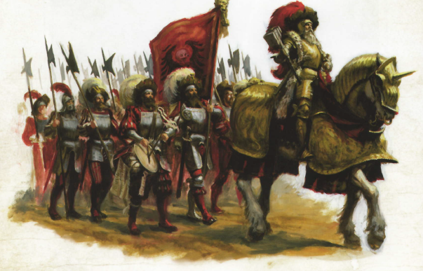

Regiment: a regiment is a group of soldiers from a military's ground forces if a group chooses this group background they have several roles to choose from and several that are mandatory. each group may only consist of members with roles relative to the makeup of the group.

sergeant

makeup: 1

proficiency: three of choice

language: one of choice

equipment: badge of position, sergeant's uniform, shortsword, hand crossbow, 10 bolts, a bottle of fine wine

soldier

makeup: 1+

proficiency: survival

language: common

equipment: short sword, leather armor, health potion, soldiers uniform

specialist

makeup: 0-3

proficiency: two skills of your choice

language: one language of your choice

equipment: any two martial or melee weapons, 20 ammunition of your choice, 3 health potions or 3 vials of poison, soldiers uniform

medic

makeup: 0-1

proficiency: medicine

language: -

equipment: surgery tools, bandages,6 health potions, medics uniform



Gypsies band: a band of gypsies is a group of wanderers who have grown up travelling with their home bing the open road

gypsy duke

makeup: 1

proficiency: deception and sleight of hand

language: two of your equipment: 3 trinkets, travelers clothes, a golden locket

gypsy

makeup: 1+

proficiency: acrobatics

language: one of choice

equipment: a trinket, travelers clothes, a silver bracelet



Bard group: a group of bards travel and play music for coin and often aid in the adventures of towns and their guards

bard first seat

makeup: 1

proficiency: performance

language: three of your choice

equipment: two instruments of your choice, a set of fine clothes, a coin pouch

bard

makeup: 1+

proficiency: performance

language:one of your choice

equipment: one instrument of your choice, a set of fine clothes, a coin pouch



Warband: a warband is a savage group of warriors who work together to get loot women and power.

feature: barbarus: you have advantage on rolls to destroy non animated material

warlord

makeup: 1

proficiency: intimidation

language: orcish

equipment: leather armor, handaxe, shield, 5 rations, tent, bedroll

warrior

makeup: 1+

proficiency: survival

language: -

equipment: handaxe, 5 rations, bedroll



ship crew: a crew of a ship often filled with bruisers, cheats, and terrifying captains.

feature: seaworthy: you don't get seasick and can last 3 days longer than others without water.

captain

makeup: 1

proficiency: persuasion

language: thieves cant’ equipment: captain's uniform, 3 bottles of rum, a rapier, a pet parrot

bosun

makeup: 0-1

proficiency: intimidation

language: shanty

equipment: traveler's clothes, a whip, a bottle of rum

mariners

makeup: 1+

proficiency: athletics

language: shanty

equipment: traveler's clothes, a flask

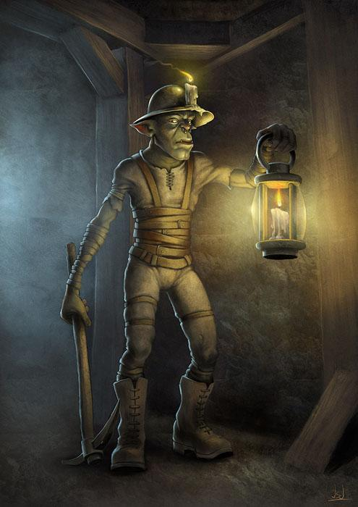

miner: a miner spends their time digging and selling what they dig up

proficiencies: sleight of hand and athletics

languages: dwarvish

equipment: a pick axe, workers clothes, a helmet with a candle clasp, 5 candles

feature: you are proficient in digging and can dig hole 50% faster than an average person.

**Armor**

You may wear multiple pieces of armor from different sets, calculate your ac for each set and average the ac between all pieces, piece types are as follows torso, leg, greaves, gauntlets, and helmet.

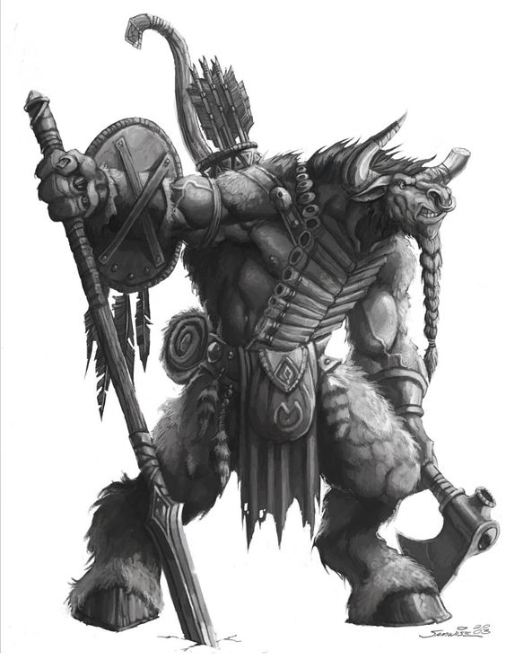

Buckler: you may wear a Buckler and have a light weapon equipped or a two handed non heavy weapon. While wielding a Buckler you get +1 ac and +1 to dexterity saving throws

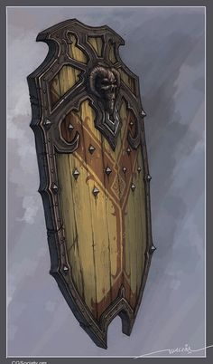

Wall shield: you must wield a wall shield in your main hand, you may only wield single handed light weapons with a wall shield. While wielding a wall shield increase your AC by 4.

**Weapons**

Armor piercing: the ac of the target becomes 10+their dexterity modifier against this weapon

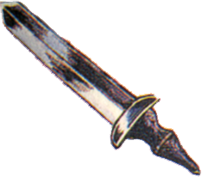

|  |  |  |  |  |
| --- | --- | --- | --- | --- |
| name | damage | type | cost | special abilities |
| broadsword | 1d10 | slashing | 100g | versatile(2d6) |
| heavy broadsword | 4d4 | slashing | 300g | armor piercing |

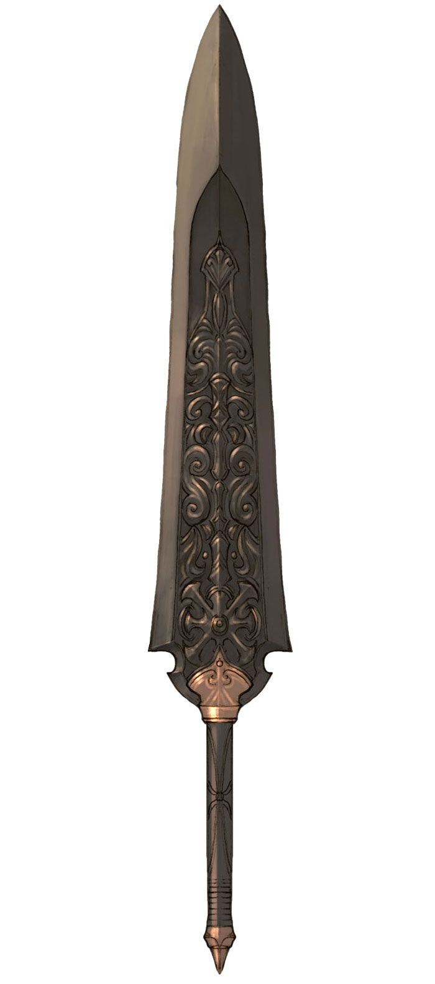

**Feats**

Firearm expert:

Requirements: proficiency with firearms

Effect: - you may load any firearm as a bonus action. – on critical hits increase one damage die by one size. – add 25 feet to the range of firearms that you use.

Cloak fighter:

Requirements: proficiency with hunters cloak

Effect: - as a reaction you may subtract your proficiency bonus from an attack targeting you. – your maximum dexterity bonus while wearing a cloak is increased by 1.

Hunter:

Effect: - you can telepathically sense the direction of magic and antimagic within 60 feet of you. – You have advantage on investigation and insight checks targeting magical creatures

Hunted:

Requirement: you must be a magical creature

Effect: - you can sense when a creature is tracking you or otherwise trying to find you within a radius of 60ft centered on you. – you can spend 10 mins to disguise yourself, for the next hour you can no longer be recognized as magical, you must take a short or long rest before you can use this ability again.

Strongman:

Requirement: strength score of at least 13

Effect: - gain proficiency in strength saving throws. – double your proficiency bonus with athletics if you are proficient in athletics. – You count as one size larger when calculating how much you can carry, push, lift or drag.

Genius:

Requirement: intelligence and wisdom score of at least 14

Effect: - you can accurately recall any information you have ever known. – You have advantage on attacks against foes that you have fought before – you have advantage on intelligence and wisdom saving throws that aren’t resisting magic

Planeswalker:

Requirement: dm must approve

Effect: - you regain all spell slots expended at dawn, as well as all magical items that you are attuned to now regain their charges at dawn, and you cannot regain spells slots normally. – you may cast plane shift as a free action without expending a spell slot, constitution is your spell casting modifier for this spell. – you may cast planar ally or any spell that begins with conjure then immediately after, cast planar binding on all creatures summoned, then expend a spell slot or gain a number of levels of exhaustion or both of the dms choice.

Courageous:

Effect: - you have advantage on saving throws that would cause you to be frightened.

Quipy:

Effect: - you have advantage on initiative and perception checks. – you speak quickly and always can talk before others in a conversation as well as being quick witted and able to come up with witty puns and jokes on the fly. – increase your speed by 5

Sex fiend

Requirement: have a charisma score of at least 17

Effect: - people find you extremely sexually desirable. – You gain advantage on persuasion checks.

Racer

Requirement: proficiency with at least one vehicle or mount

Effect: you have advantage on animal handling checks with creatures you are currently mounting. – you have advantage on dexterity checks made to drive a vehicle.

Social manipulator:

Requirement: have a charisma score of at least 15.

Effect: - you easily connect the strings of people’s feelings, you can easily manipulate and pull at peoples strings in the direction of your choice. – yo uhave advantage on persuasion and deception checks against humanoids with charisma less than yours.